CELEBRATION OF BAPTISM

218. After the Homily the Baptismal Liturgy begins. The Priest goes with the ministers to the baptismal font, if this can be seen by the faithful. Otherwise a vessel with water is placed in the sanctuary.

PRESENTATION OF THOSE TO BE BAPTIZED

219. Accordingly, one of the following procedures, options A, B, or C, is chosen for the presentation of those to be baptized.

A

When Baptism Is Celebrated Immediately at the Baptismal Font

The Priest goes with the ministers to the baptismal font. The elect are called forward and presented by their godparents in front of the assembled Church. Those to be baptized and their godparents go to the font, which they stand around in such a way that they do not block the view of the faithful. The celebrant's Instruction (no. 220) and the Litany (no. 221) follow.

If, however, there are many to be baptized, they may approach while the Litany is being sung.

B

When Baptism Is Celebrated after a Procession to the Font

The elect are called forward and presented by their godparents in front of the assembled Church. The procession to the baptistery or to the font forms immediately. A minister with the paschal candle leads off (unless outside the Easter Vigil, it already rests at the baptismal font), and those to be baptized follow him with their godparents, then the ministers, the Deacon, and the Priest. During the procession, the Litany (no. 221) is sung. When the procession has reached the font, those to be baptized and their godparents stand around the font in such a way that they do not block the view of the faithful. When the Litany is completed, the Priest gives the address (no. 220).

If there are a great many to be baptized, they and their godparents simply take their place in the procession.

C

When Baptism Is Celebrated in the Sanctuary

The elect are called forward and presented by their godparents in front of the assembled Church. Those to be baptized and their godparents take their place before the celebrant in the sanctuary, in such a way that they do not block the view of the faithful. The celebrant's Instruction (no. 220) and the Litany (no. 221) follow.

If, however, there are many to be baptized, they may approach while the Litany is being sung.

CELEBRANT'S INSTRUCTION

220. The celebrant, addressing those present, makes use of one of the following or a similar instruction:

A

Dear brothers and sisters,
let us beg the mercy of God the almighty Father,
for these servants of God N. and N.,
who are seeking holy Baptism.
May God bestow light and strength
on those whom he has called and led to this hour,
that they may hold fast to Christ with resolute spirit
and profess the faith of the Church.
May he also give them renewal by the Holy Spirit,
whom we will fervently invoke upon this water.

B

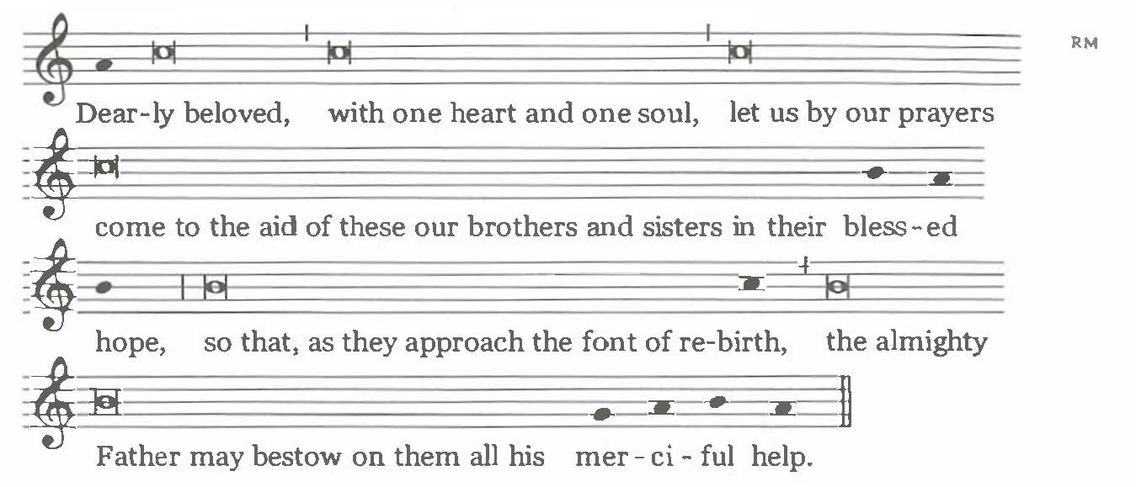

Dearly beloved,
with one heart and one soul, let us by our prayers
come to the aid of these our brothers and sisters in their blessed hope,
so that, as they approach the font of rebirth,
the almighty Father may bestow on them
all his merciful help.

LITANY

221. The Litany is sung by two cantors, with all standing (because it is Easter Time) and responding. In the Litany the names of some Saints may be added, especially the Titular Saint of the church and the Patron Saints of the place and of those to be baptized.

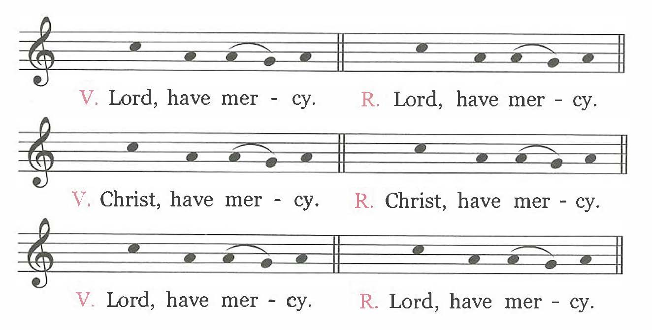

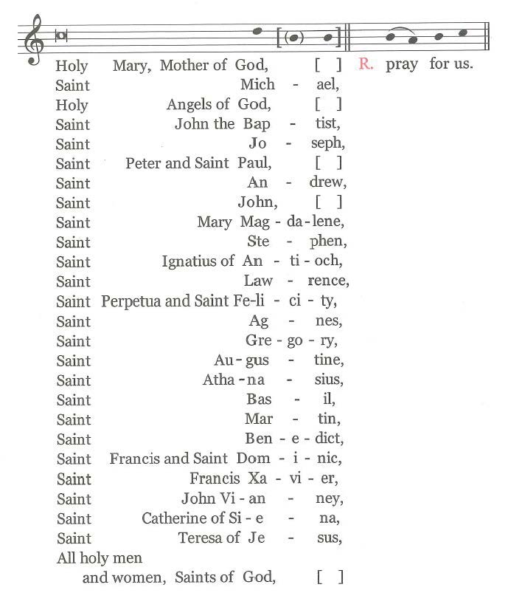

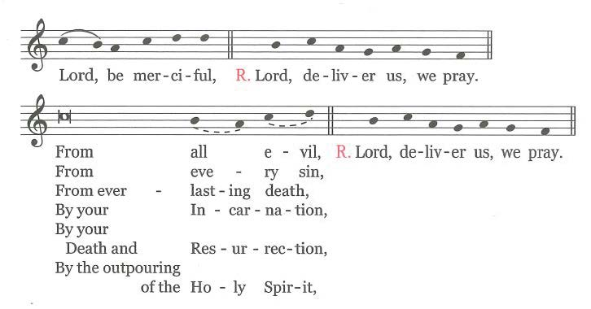
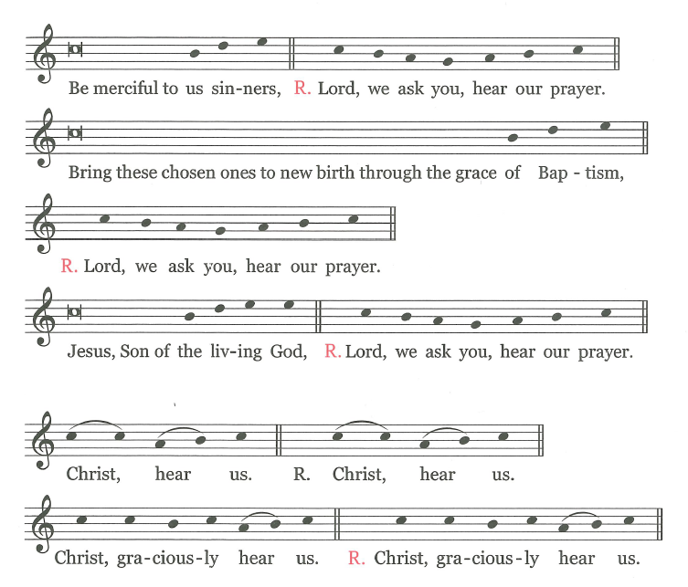

The Priest, with hands extended, says the following prayer:

Almighty ever-living God,
be present by the mysteries of your great love
and send forth the spirit of adoption
to create the new peoples
brought to birth for you in the font of Baptism,
so that what is to be carried out by our humble service
may be brought to fulfillment by your mighty power.
Through Christ our Lord.

℟. Amen.

BLESSING OF WATER

222. Next, the celebrant turns toward the font and says the Blessing given in option A with hands extended.

When Baptism is celebrated outside the Easter Vigil (cf. no. 26), the celebrant may use any of the blessing formulas given in options A, B, and C.

During Easter Time (cf. no. 26), however, if baptismal water blessed at the Easter Vigil is available, so that the Baptism may not lack an element of thanksgiving and petition, the Blessing and Invocation of God over the Water takes place in accordance with the formulas given in option D or option E.

A

BLESSING OF WATER: The celebrant turns toward the font and says the following
Blessing with hands extended:
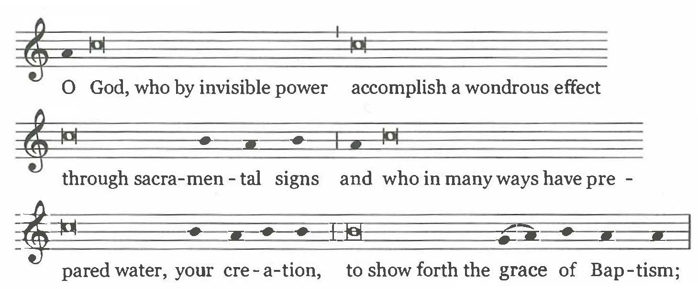
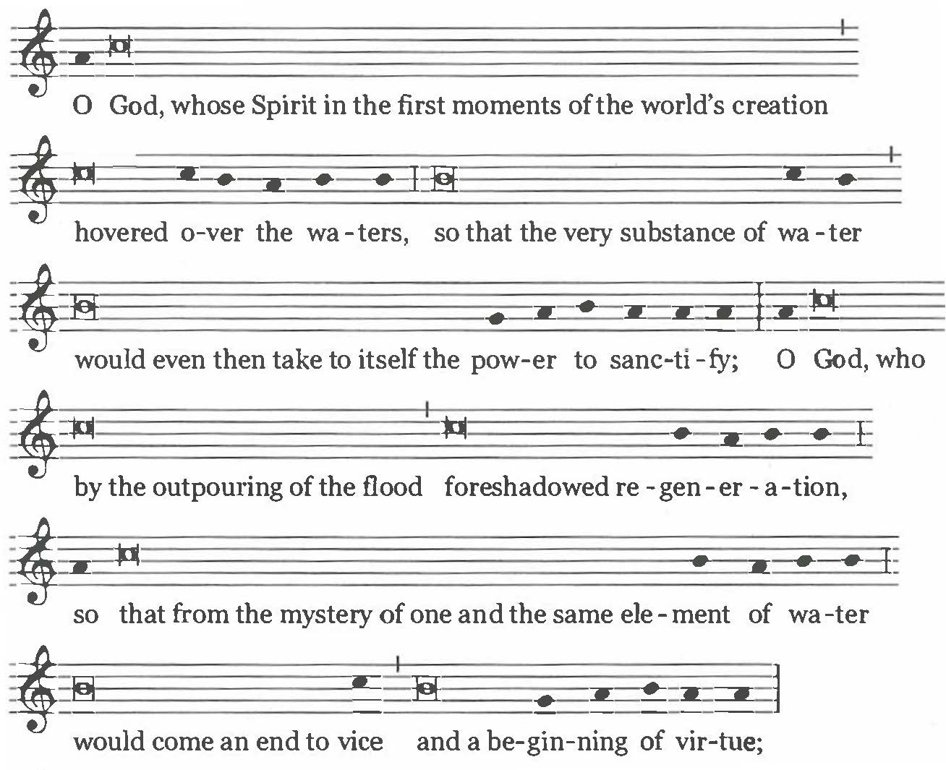
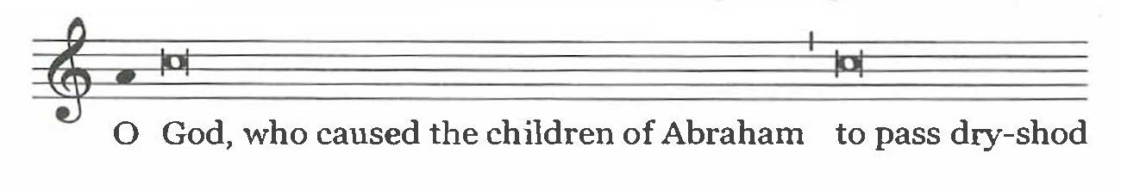
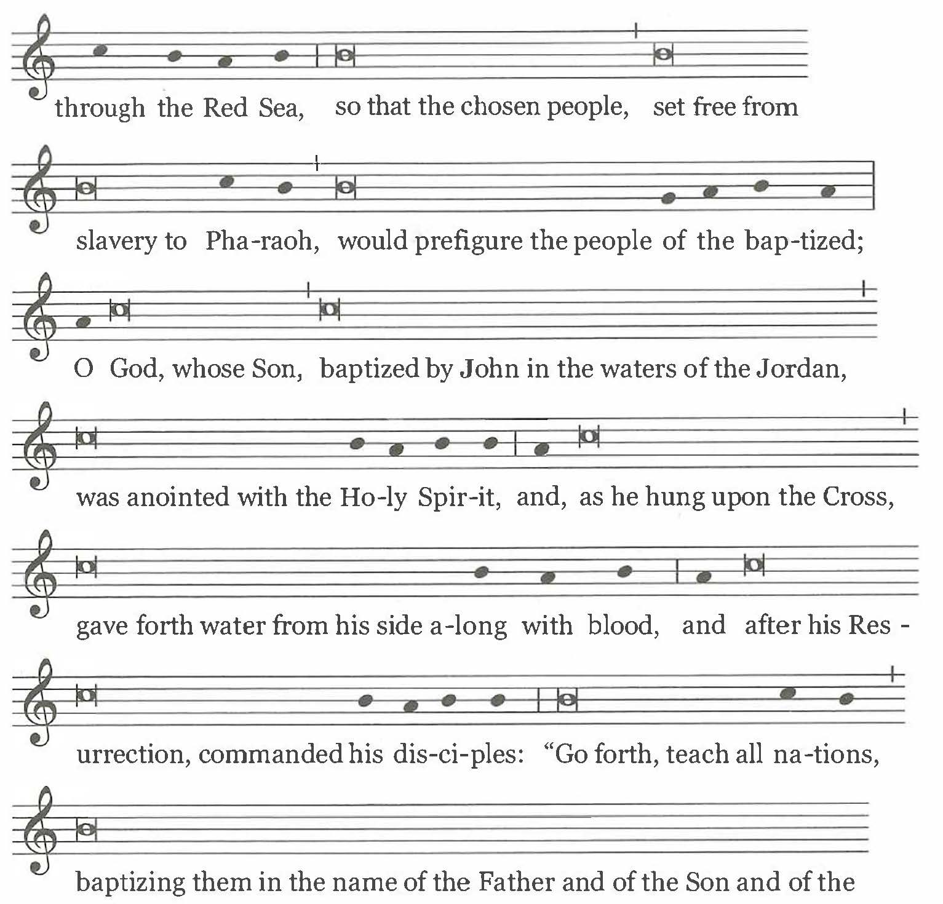
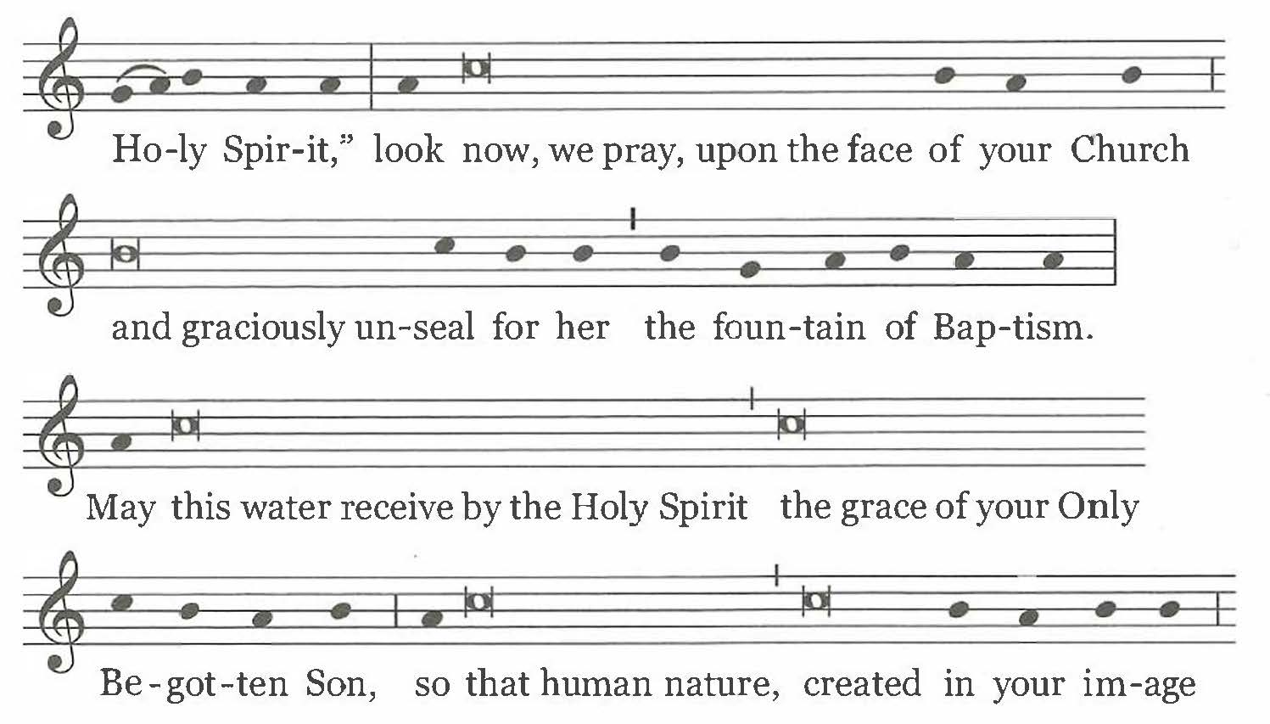

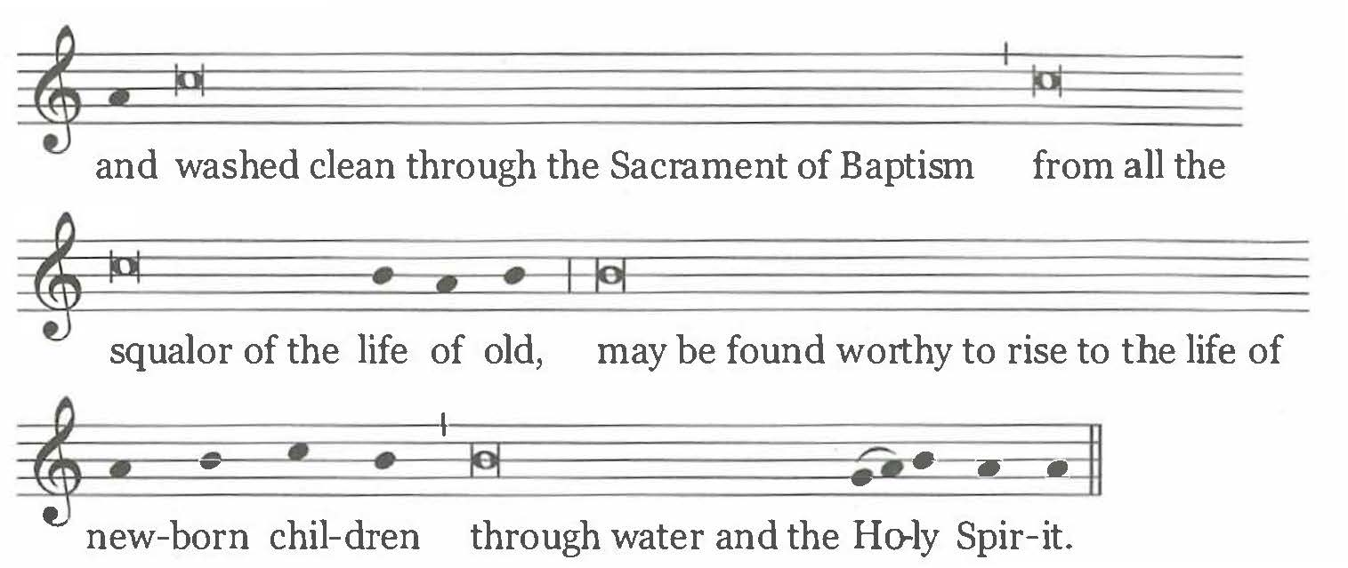

And, if appropriate, lowering the paschal candle into the water either once or three times, he continues:

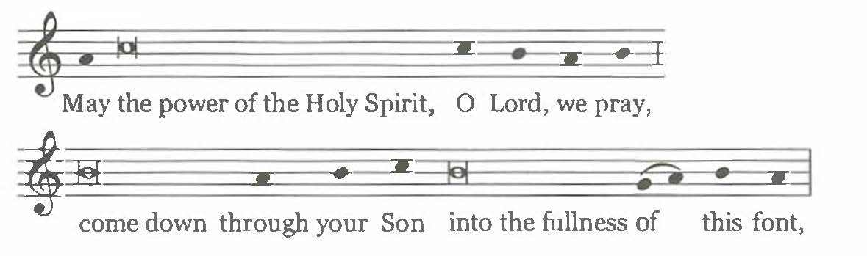

and, holding the candle in the water, he continues:

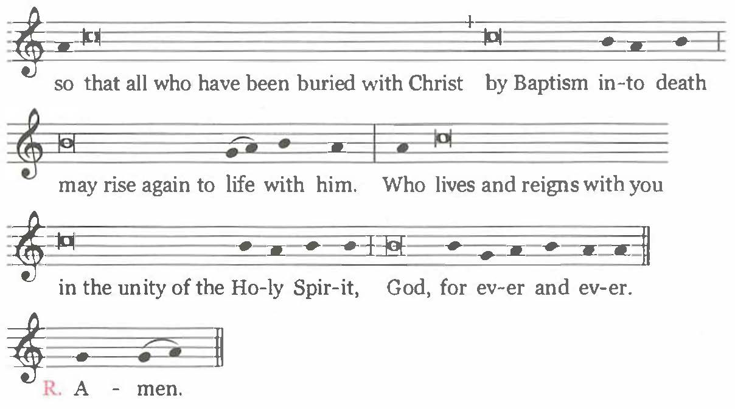

Text without music:

O God, who by invisible power
accomplish a wondrous effect
through sacramental signs
and who in many ways have prepared water, your creation,
to show forth the grace of Baptism;

O God, whose Spirit
in the first moments of the world's creation
hovered over the waters,
so that the very substance of water
would even then take to itself the power to sanctify;

O God, who by the outpouring of the flood
foreshadowed regeneration,
so that from the mystery of one and the same element of water
would come an end to vice and a beginning of virtue;

O God, who caused the children of Abraham
to pass dry-shod through the Red Sea,
so that the chosen people,
set free from slavery to Pharaoh,
would prefigure the people of the baptized;

O God, whose Son,
baptized by John in the waters of the Jordan,
was anointed with the Holy Spirit,
and, as he hung upon the Cross,
gave forth water from his side along with blood,
and after his Resurrection, commanded his disciples:
"Go forth, teach all nations, baptizing them
in the name of the Father and of the Son and of the Holy Spirit,"
look now, we pray, upon the face of your Church
and graciously unseal for her the fountain of Baptism.

May this water receive by the Holy Spirit
the grace of your Only Begotten Son,
so that human nature, created in your image
and washed clean through the Sacrament of Baptism
from all the squalor of the life of old,
may be found worthy to rise to the life of newborn children
through water and the Holy Spirit.
And, if appropriate, lowering the paschal candle into the water either once or three times, he continues:

May the power of the Holy Spirit,
O Lord, we pray,
come down through your Son
into the fullness of this font,

and, holding the candle in the water, he continues:

so that all who have been buried with Christ
by Baptism into death
may rise again to life with him.
Who lives and reigns with you in the unity of the Holy Spirit,
God, for ever and ever.

℟. Amen.

Then the candle is lifted out of the water, as the people acclaim:

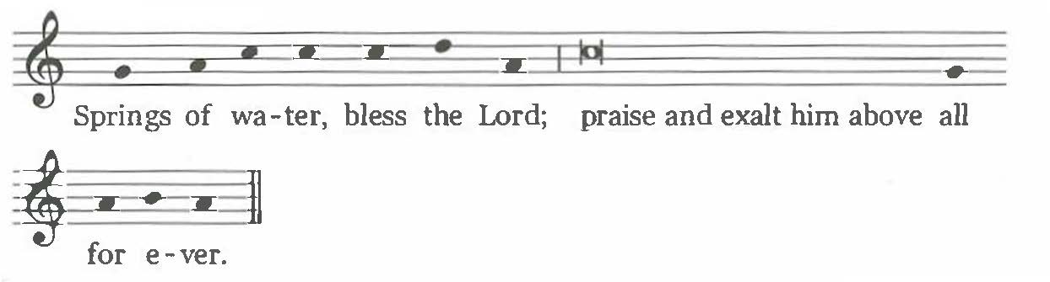

Springs of water, bless the Lord;
praise and exalt him above all for ever.

B

BLESSING OF WATER: The celebrant turns toward the font and says the following
Blessing with hands extended:

Blessed are you, God the almighty Father,
for you have created water to cleanse and give life.

All: Blessed be God (or another suitable acclamation of the people).
Celebrant:

Blessed are you, God the Only Begotten Son, Jesus Christ,
for you poured forth water with blood from your side,
so that from your Death and Resurrection the Church might be born.

All: Blessed be God.

Celebrant:

Blessed are you, God the Holy Spirit,
for you anointed Christ at his baptism in the waters of the Jordan,
that we might all be baptized into you.

All: Blessed be God.

Celebrant:

Draw near to us, Lord, the one Father,
and sanctify this water you have created,
that those baptized in it may be washed clean of sin
and be born again to the life of your adopted children.

All: Hear us, O Lord (or another suitable invocation of the people).

Celebrant:

Sanctify this water you have created,
that those baptized through it
into Christ's Death and Resurrection
may be conformed to the image of your Son.

All: Hear us, O Lord.

The celebrant touches the water with his right hand and continues:

Sanctify this water you have created,
that those you have chosen
may be born again by the Holy Spirit
and have a portion among your holy people .
All: Hear us, O Lord.

C

BLESSING OF WATER: The celebrant turns toward the font and says the following
Blessing with hands extended:

Most merciful Father,
from the font of Baptism,
you have made the new life of your children
well up within us.

All: Blessed be God (or another suitable acclamation of the people).

Celebrant:

You have been pleased to unite
by water and the Holy Spirit
all the baptized into one people in your Son Jesus Christ.

All: Blessed be God.

Celebrant:

You free us by the Spirit of your love,
whom you pour into our hearts,
so that we may delight in your peace.

All: Blessed be God.

Celebrant:

You choose the baptized,
that they may joyfully proclaim to all the nations
the Gospel of your Christ.
All: Blessed be God.

Celebrant:

Be pleased now to bless ✠ this water,
by which your servants (N. and N.) are to be baptized,
for you have called them to this cleansing water of rebirth
in the faith of the Church,
that they may have eternal life.
Through Christ our Lord.

All: Amen.

D

EASTER TIME THANKSGIVING OVER WATER ALREADY BLESSED: The celebrant
turns toward the font containing the blessed water and says the following:

Blessed are you, God the almighty Father,
for you have created water to cleanse and give life.

All: Blessed be God (or another suitable acclamation of the people).

Celebrant:

Blessed are you, God the Only Begotten Son, Jesus Christ,
for you poured forth water with blood from your side,
so that from your Death and Resurrection
the Church might be born.

All: Blessed be God.

Celebrant:

Blessed are you, God the Holy Spirit,
for you anointed Christ at his baptism in the waters of the Jordan,
that we might all be baptized into you.

All: Blessed be God.

Celebrant:

By the mystery of this blessed water,
graciously lead to spiritual rebirth your servants (N. and N.),
whom you have called to this cleansing water,
that they may have eternal life.
Through Christ our Lord.

All: Amen.

E

EASTER TIME THANKSGIVING OVER WATER ALREADY BLESSED: The celebrant
turns toward the font containing the blessed water and says the following:

Most merciful Father,
from the font of Baptism,
you have made the new life of your children
well up within us.

All: Blessed be God (or another suitable acclamation).

Celebrant:

You have been pleased to unite
by water and the Holy Spirit
all the baptized into one people in your Son Jesus Christ.
All: Blessed be God.

Celebrant:

You free us by the Spirit of your love,
whom you pour into our hearts,
so that we may delight in your peace.

All: Blessed be God.

Celebrant:

You choose the baptized,
that they may joyfully proclaim to all the nations
the Gospel of your Christ.

All: Blessed be God.

Celebrant:

By the mystery of this blessed water,
graciously lead to spiritual rebirth your servants (N. and N.),
whom you have called to this cleansing water,
that they may have eternal life.
Through Christ our Lord.

All: Amen.

PROFESSION OF FAITH

223. After the consecration of the font (or prayer of thanksgiving}, the celebrant continues with the Profession of Faith, which includes the Renunciation of Sin and the Profession itself.

RENUNCIATION OF SIN

224. As circumstances suggest, the celebrant, informed by the godparents of the name of each person to be baptized, asks each of them, choosing any one of the three formulas below; or he may use the same formulas to question all of the elect together.

At the discretion of the Diocesan Bishop, the formulas for the Renunciation of Sin may be made more specific and detailed as circumstances might require (cf no. 33.8).

A

Celebrant:

Do you renounce sin,
so as to live in the freedom of the children of God?

Elect: I do.

Celebrant:
Do you renounce the lure of evil,
so that sin may have no mastery over you?

Elect: I do.
Celebrant:

Do you renounce Satan,
the author and prince of sin?

Elect: I do.

B

Celebrant:

Do you renounce Satan,
and all his works and empty promises?

Elect: I do.

C

Celebrant:

Do you renounce Satan?

Elect: I do.

Celebrant:

And all his works?

Elect: I do.

Celebrant:

And all his empty show?

Elect: I do.

PROFESSION OF FAITH

225. Then the celebrant, informed again by the godparents of the name of each to be baptized, questions the elect individually.
When there are a great many to be baptized, the Profession of Faith may be made simultaneously either by all together or group by group.

Celebrant:

N., do you believe in God,
the Father almighty,
Creator of heaven and earth?

Elect: I do.

Celebrant:

Do you believe in Jesus Christ, his only Son, our Lord,
who was born of the Virgin Mary,
suffered death and was buried,
rose again from the dead
and is seated at the right hand of the Father?

Elect: I do.

Celebrant:

Do you believe in the Holy Spirit,
the holy catholic Church,
the communion of saints,
the forgiveness of sins,
the resurrection of the body,
and life everlasting?

Elect: I do.

RITE OF BAPTISM

226. After the Profession of Faith, each elect is immediately baptized by immersion (option A) or by the pouring of water (option B). After the Baptism of each adult, a brief acclamation (cf. Appendix II, nos. 595-597) may be sung by the people.

When there are a great number of the elect to be baptized, if there are several Priests or Deacons present, those to be baptized may be divided into groups among the individual ministers. In baptizing, either by immersion (option A) or by the pouring of water (option B) these ministers say the sacramental formula for each one. While the rite is taking place, singing by the people is desirable; it is also permitted to have readings or to observe sacred silence.

A

If Baptism is by immersion of the whole body or of the head only, decency and decorum should be observed. Either or both godparents touch the one to be baptized. Touching the elect, the celebrant immerses him (her) or his (her) head three times, raising the elect out of the water each time and baptizing him (her) by calling upon the Most Holy Trinity only once:

N., I BAPTIZE YOU IN THE NAME OF THE FATHER,

He immerses the elect the first time.

AND OF THE SON,

He immerses the elect the second time.

AND OF THE HOLY SPIRIT.

He immerses the elect the third time.

B

If, however, Baptism is by the pouring of water, either or both godparents place the right hand on the right shoulder of the one to be baptized, and the celebrant, taking baptismal water and pouring it three times on the person's bowed head, baptizes him (her) in the name of the Most Holy Trinity:

N., I BAPTIZE YOU IN THE NAME OF THE FATHER,

He pours water the first time.

AND OF THE SON,

He pours water the second time.

AND OF THE HOLY SPIRIT.

He pours water the third time.

EXPLANATORY RITES

227. The Explanatory Rites (nos. 228-230) are carried out immediately after Baptism. After these rites, Confirmation normally is celebrated, as described below (nos. 231-235), in which case the Anointing after Baptism is omitted.

ANOINTING AFTER BAPTISM

228. If for some special reason, the celebration of Confirmation is separated from the Baptism (cf. no. 215), then, after the immersion or the pouring of water, the celebrant administers the Anointing with Chrism in the usual way. If, however, there are a large number of newly baptized and several Priests or Deacons are present, each of them may anoint some of the newly baptized with Chrism.

The celebrant says the following over all the newly baptized:

Almighty God, the Father of our Lord Jesus Christ,
has given you new birth by water and the Holy Spirit,
granted you the remission of all sins,
and joined you to his people.
He now anoints you with the Chrism of salvation,
so that you may remain members of Christ, Priest, Prophet and King,
unto eternal life.

The newly baptized: Amen.

Then, in silence, the celebrant anoints each of the newly baptized with sacred Chrism on the crown of the head.

CLOTHING WITH A WHITE GARMENT

229. The celebrant says the following formula. At the words Receive, therefore, the white garment the godparents place the white garment on the newly baptized, unless another color more suited to local custom should be required. If circumstances suggest, this rite can be omitted.

Celebrant:

N. and N., you have become a new creation
and have clothed yourselves in Christ.
Receive, therefore, the white garment
and bring it unstained
before the judgment seat of our Lord Jesus Christ,
that you may have eternal life.

The newly baptized: Amen.

HANDING ON OF A LIGHTED CANDLE

230. The celebrant then takes the paschal candle in his hands or touches it, saying:

Come forward, godfathers and godmothers,
that you may hand on the light to the newly baptized.

A godparent of each of the neophytes goes to the celebrant, lights a candle from the paschal candle, and presents it to the neophyte.

Then the celebrant says:

You have been made light in Christ.
Walk always as children of light,
that persevering in faith
you may run to meet the Lord when he comes
with all the Saints in the heavenly court.

The newly baptized: Amen.

If the celebration of Confirmation is to be deferred, the renewal of baptismal promises, as in The Roman Missal, The Easter Vigil (no. 55), now takes place; then the neophytes are led back to their places among the faithful.

Outside the Easter Vigil if Confirmation is to be deferred, the neophytes are led back to their places among the faithful after the presentation of a lighted candle.

CELEBRATION OF CONFIRMATION

231. Unless the baptismal washing and the other Explanatory Rites have occurred in the sanctuary, a procession returns to the sanctuary, formed as before, with the newly baptized or the godparents or parents carrying lighted candles. During this procession, the baptismal canticle Vidi aquam (I saw water) or another appropriate chant is sung (The Roman Missal, The Easter Vigil, no. 56).

232. If the Bishop has conferred Baptism, he should now also administer Confirmation. If the Bishop is not present, Confirmation is to be given by the Priest who conferred Baptism (cf. Code of Canon Law, can. 866).

When those to be confirmed are too numerous, Priests who may be designated for this role can be associated to the minister of Confirmation to administer the Sacrament (cf. no.14).

INVITATION

233. The celebrant briefly addresses the neophytes, in these or similar words:

Dear neophytes, you have been born again in Christ,
and have become members of Christ and of his priestly people.
Now you are to share
in the outpouring among us of the Holy Spirit,
who was sent by the Lord upon the Apostles at Pentecost
to be given by them and their successors to the baptized.

Therefore, you also are to receive the promised power of the Holy Spirit,
so that, being more perfectly conformed to Christ,
you may bear witness to the Lord's Passion and Resurrection
and become an active member of the Church
for the building up of the Body of Christ in faith and charity.
Then the celebrant (while the Priests associated with him remain by his side) standing, facing the people, with hands joined, says:

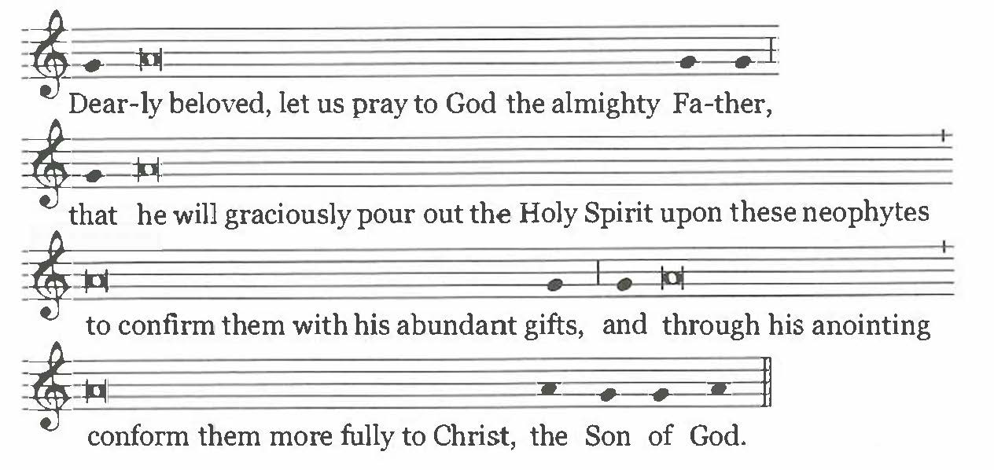

Dearly beloved,
let us pray to God the almighty Father,
that he will graciously pour out the Holy Spirit
upon these neophytes
to confirm them with his abundant gifts,
and through his anointing
conform them more fully to Christ, the Son of God.

And all pray in silence for a while.

THE LAYING ON OF HANDS

234. Then the celebrant lays hands over all those to be confirmed (as do the Priests who are associated with him). But the celebrant alone says:

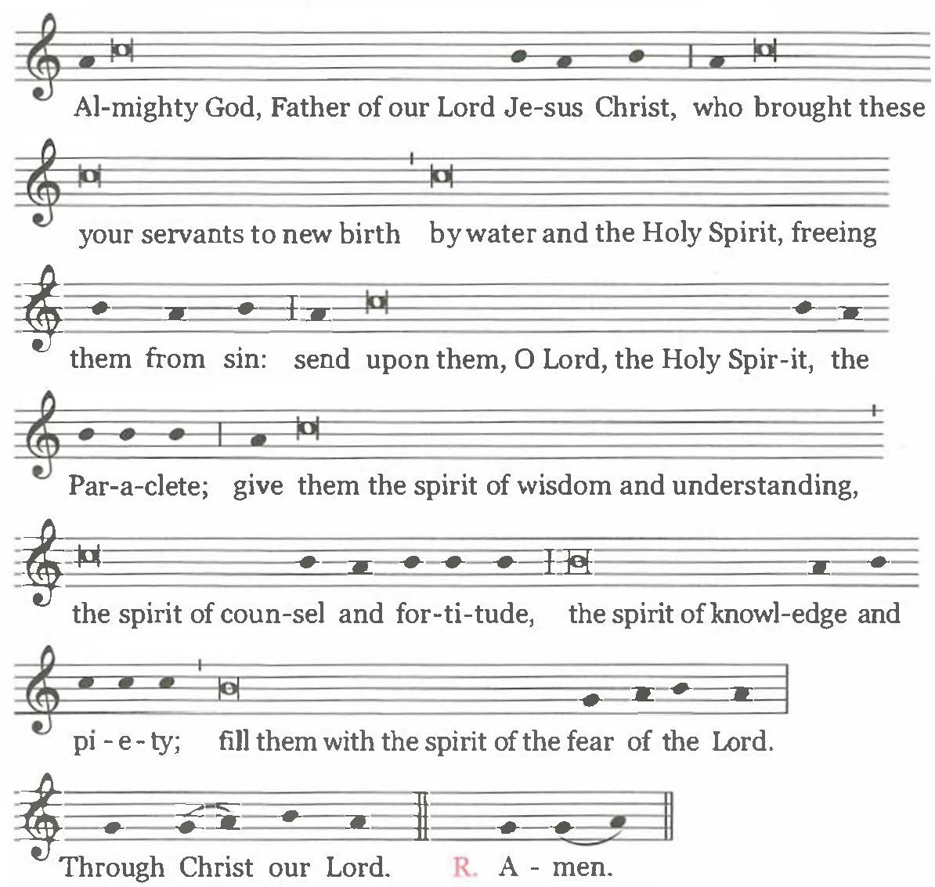

Almighty God, Father of our Lord Jesus Christ,
who brought these your servants to new birth
by water and the Holy Spirit,
freeing them from sin:
send upon them, O Lord, the Holy Spirit, the Paraclete;
give them the spirit of wisdom and understanding,
the spirit of counsel and fortitude,
the spirit of knowledge and piety;
fill them with the spirit of the fear of the Lord.
Through Christ our Lord.

All: Amen.

THE ANOINTING WITH CHRISM

235. The sacred Chrism is brought by a minister to the celebrant.

If other Priests are associated with the celebrant in conferring the Sacrament, the vessels of sacred Chrism are given to them by the Bishop, if he is present.

Each of those to be confirmed goes to the celebrant (or to the Priests); or, if appropriate, the celebrant (and the Priests) goes to each of those to be confirmed. In addition, the godparent places his (her) right hand on the shoulder of the one to be confirmed and says his (her) name to the celebrant; or the one to be confirmed alone says his (her) own name. During the anointing a suitable chant may be sung.

The celebrant dips the tip of the thumb of his right hand in the Chrism and, with the thumb, makes the Sign of the Cross on the forehead of the one to be confirmed, as he says:

N., BE SEALED WITH THE GIFT OF THE HOLY SPIRIT.

The newly confirmed: Amen.

The celebrant adds:

Peace be with you.

The newly confirmed: And with your spirit.

236. At the Easter Vigil the renewal of baptismal promises by the congregation follows the celebration of Confirmation (nos. 237-240 below; The Roman Missal, The Easter Vigil, no. 55). Then the neophytes are led to their places among the faithful.

Outside the Easter Vigil, the neophytes are led to their places among the faithful immediately after Confirmation. The Universal Prayer (Prayer of the Faithful) then begins (cf. no. 241).

RENEWAL OF BAPTISMAL PROMISES
(AT THE EASTER VIGIL)

INVITATION
237. When the Rite of Baptism (and Confirmation) has been completed, all stand, holding lighted candles in their hands, and renew the promise of baptismal faith, unless this has already been done together with those to be baptized (cf. The Roman Missal, The Easter Vigil, no. 49). The Priest addresses the faithful in these or similar words:
Dear brethren (brothers and sisters), through the Paschal Mystery
we have been buried with Christ in Baptism,
so that we may walk with him in newness of life.
And so, now that our Lenten observance is concluded,
let us renew the promises of Holy Baptism,
by which we once renounced Satan and his works
and promised to serve God in the holy catholic Church.
And so I ask you:

RENUNCIATION OF SIN

238. The celebrant continues with one of the following formulas of renunciation.

If the situation warrants, formula A may be adapted by the Conference of Bishops according to local needs.

A

Celebrant:

Do you renounce sin,
so as to live in the freedom of the children of God?

All: I do.

Celebrant:

Do you renounce the lure of evil,
so that sin may have no mastery over you?

All: I do.

Celebrant:

Do you renounce Satan,
the author and prince of sin?

All: I do.

B
Celebrant:

Do you renounce Satan?

All: I do.

Celebrant:

And all his works?

All: I do.

Celebrant:

And all his empty show?

All: I do.

PROFESSION OF FAITH

239. Then the celebrant continues:

Do you believe in God,
the Father almighty,
Creator of heaven and earth?

All: I do.

Celebrant:

Do you believe in Jesus Christ, his only Son, our Lord,
who was born of the Virgin Mary,
suffered death and was buried,
rose again from the dead
and is seated at the right hand of the Father?

All: I do.

Celebrant:

Do you believe in the Holy Spirit,
the holy catholic Church,
the communion of saints,
the forgiveness of sins,
the resurrection of the body,
and life everlasting?

All: I do.

And the celebrant concludes:

And may almighty God, the Father of our Lord Jesus Christ,
who has given us new birth by water and the Holy Spirit
and bestowed on us forgiveness of our sins,
keep us by his grace,
in Christ Jesus our Lord,
for eternal life.

All: Amen.

SPRINKLING WITH BAPTISMAL WATER

240. The celebrant sprinkles the people with the blessed water, while all sing the following or another chant that is baptismal in character:

I saw water flowing from the Temple,
from its right-hand side, alleluia;
and all to whom this water came were saved
and shall say: Alleluia, alleluia. (Cf Ez 47:1-2, 9)

CELEBRATION OF THE EUCHARIST

241. The Creed is omitted, and the Universal Prayer (Prayer of the Faithful), which the neophytes take part in for the first time, immediately takes place. When the offerings are carried to the altar, some of the neophytes may bring them forward.

242. In Eucharistic Prayer I, mention of the neophytes is made in the proper form of the Hanc igitur (Therefore, Lord, we pray), at the Easter Vigil from The Roman Missal, Order of Mass, no. 87, and outside the Easter Vigil from the Ritual Mass for the Conferral of Baptism. At the Easter Vigil and outside the Easter Vigil, in Eucharistic Prayer I, mention of the godparents is made in the section Memento, Domine (Remember, Lord, your servants) from the Ritual Mass for the Conferral of Baptism. If Eucharistic Prayer II, III, or IV is used, the proper formula for the neophytes is used from the Ritual Mass for the Conferral of Baptism.

243. It is desirable that the neophytes receive Holy Communion under both kinds, together with their godfathers, godmothers, and Catholic parents and spouses, as well as their lay catechists. It is even appropriate that, with the consent of the Diocesan Bishop, where the occasion suggests this, all the faithful be admitted to Holy Communion under both kinds.

Before Communion, that is, before Ecce Agnus Dei (Behold the Lamb of God), the celebrant may briefly remind the neophytes of the preeminence of so great a Sacrament, which is the climax of their Initiation and the center of the whole Christian life. He may do so in these or other words:

Dear neophytes,
(on this most sacred night)
you have been reborn by water and the Holy Spirit,
and will receive, for the first time,
the Bread of life and the Chalice of salvation.

May the Body and Blood of Christ the Lord
help you all to grow deeper in his friendship
and in communion with the entire Church;
may it be your constant food for the journey of life
and a foretaste of the eternal banquet of heaven.

Behold the Lamb of God . . .

