CELEBRATION AT THE EASTER VIGIL OF
THE SACRAMENTS OF INITIATION AND
THE RITE OF RECEPTION

562. Pastoral considerations may suggest that along with the celebration of the Sacraments of Christian Initiation of adults, the Easter Vigil should include the Rite of Reception into the full communion of the Catholic Church of those already validly baptized, and even the Baptism of children. But such a decision must be guided by the theological and pastoral directives proper to each rite.
The model provided here simply arranges the ritual elements belonging to such a combined celebration. But the model can only be used properly in the light of nos. 206-217, regarding celebration of the Sacraments of Christian Initiation, of nos. 400-410, regarding the Confirmation of Catholics previously baptized as infants, and of nos. 473-486, regarding the Rite of Reception into the full communion of the Catholic Church.
If the Baptism of children will take place along with the Initiation of adults, it should do so in light of the Introduction to the Order of Baptism of Children, with special attention given to no. 28.1, which describes elements of the ritual that are to be carried out in anticipation of the Easter Vigil.

563. Inclusion at the Easter Vigil of the Rite of Reception into full communion may also be opportune liturgically, especially when the candidates have undergone a lengthy period of spiritual formation coinciding with Lent. In the liturgical year the Easter Vigil, the preeminent commemoration of Christ's Paschal Mystery, is the preferred occasion for the celebration in which the elect will enter the Paschal Mystery through Baptism, Confirmation, and the Eucharist. Candidates for Reception, who in Baptism have already been justified by faith and incorporated into Christ, are entering fully into a community
that is constituted by its communion both in faith and in the sacramental sharing of the Paschal Mystery. The celebration of their Reception at the Easter Vigil provides the candidates with a privileged opportunity to recall and reaffirm their own Baptism, "the sacramental bond of unity" and "the foundation of communion between all Christians."
At the Easter Vigil these candidates can make their profession of faith by joining the community in the renewal of the baptismal promises, and, if they have not yet been confirmed, they can receive the Sacrament of Confirmation, which is intimately connected with Baptism. Since of its nature Baptism points to complete entrance into Eucharistic Communion, the baptismal themes of the Easter Vigil can serve to emphasize why the high point of the candidates' Reception is their sharing in the Eucharist with the Catholic community for the first time (cf. no. 475.1).

564. The decision to combine the two celebrations at the Easter Vigil must be guided by the provision in the Introduction of the Rite of Reception (no. 475.2). The decision should, then, be consistent in the actual situation with respect for ecumenical values and be guided by attentiveness both to local conditions and to personal and family preferences. The person to be received should always be consulted about the form of Reception (cf. no. 475.2). For a theological and liturgical introduction to the celebration of the Sacraments of Initiation at the Easter Vigil see above, nos. 206-217.

565. In its actual arrangement the celebration itself must reflect the status of candidates for Reception into the full communion of the Catholic Church: such candidates have already been incorporated into Christ in Baptism and anything that would equate them with catechumens is to be absolutely avoided (cf. no. 477).

INTRODUCTORY RITES AND LITURGY OF THE WORD

566. Those who will be received into full communion at the Easter Vigil along with their sponsors, should take places apart from the elect who will be called forward for the celebration of Baptism.

The Homily should include reference not only to the Sacraments of Initiation but also to Reception into full communion (cf no. 489).

CELEBRATION OF BAPTISM

567. After the Homily the Baptismal Liturgy begins. The Priest goes with the ministers to the baptismal font, if this can be seen by the faithful. Otherwise a vessel with water is placed in the sanctuary.

Before the presentation of the elect for Baptism, the celebrant, making necessary adjustments according to the number and categories of those being initiated, may address the congregation in these or similar words:

Dear friends,
this evening the Church welcomes diverse groups of people
to the Sacraments of Initiation.
For each of these, we give thanks and praise to God
who has led them by various paths to unity in faith.
First, we welcome our elect:
they will be initiated into the Christian faith tonight
through the Sacraments of Baptism, Confirmation, and the Eucharist.
We will pray for them and they will profess our faith,
and they will receive the gift of new life in Christ.

If children are also to be baptized the celebrant may add, in these or similar words:

And on this day in which the Church commemorates
the Resurrection of the Lord,
we also welcome parents and godparents who have
brought their children here
to give thanks to God for the gift of life
and to celebrate new birth in the waters of Baptism.

PRESENTATION OF THOSE TO BE BAPTIZED

568. Accordingly, one of the following procedures, options A, B, or C, is chosen for the presentation of those to be baptized.

A

When Baptism Is Celebrated Immediately at the Baptismal Font

The elect are called forward and presented by their godparents in front of the assembled Church or, if they are small children, are carried by their parents and godparents. Those to be baptized and their godparents go to the font, which they stand around in such a way that they do not block the view of the faithful. The celebrant's Instruction (no. 569) and the Litany (no. 570) follow.

If, however there are many to be baptized, they may approach while the Litany is being sung.

B

When Baptism Is Celebrated after a Procession to the Font

The elect are called forward and presented by their godparents in front of the assembled Church or, if they are small children, are carried by their parents and godparents. The procession to the baptistery or to the font forms immediately. A minister with the paschal candle leads off, and those to be baptized follow him with their godparents, then the ministers, the Deacon, and the Priest. During the procession, the Litany (no. 570) is sung. When the procession has reached the font, those to be baptized and their godparents stand around the font in such a way that they do not block the view of the faithful. When the Litany is completed, the Priest gives the address (no. 569).

If there are a great many to be baptized, they and their godparents simply take their place in the procession.

C

When Baptism Is Celebrated in the Sanctuary

The elect are called forward and presented by their godparents in front of the assembled Church or, if they are small children, are carried by their parents and godparents. Those to be baptized and their godparents take their place before the celebrant in the sanctuary, in such a way that they do not block the view of the faithful. The celebrant's Instruction (no. 569) and the Litany (no. 570) follow.

If, however there are many to be baptized, they may approach while the Litany
is being sung.

CELEBRANT'S INSTRUCTION

569. The celebrant, addressing those present, makes use of this or a similar instruction:

Dear brothers and sisters,
let us beg the mercy of God the almighty Father,
for these servants of God N. and N.,
who are seeking holy Baptism.
May God bestow light and strength
on those whom he has called and led to this hour,
that they may hold fast to Christ with resolute spirit
and profess the faith of the Church.
May he also give them renewal by the Holy Spirit,
whom we will fervently invoke upon this water.

If there are children to be baptized, he may add, in these or similar words:

And let us also invoke the mercy of God
for these children (N. and N.) about to receive the grace of Baptism,
and for their parents, godparents, and all the baptized.

LITANY

570. The Litany is sung by two cantors, with all standing (because it is Easter Time) and responding (for the chant, cf. no. 221). In the Litany the names of some Saints may be added, especially the Titular Saint of the church and the Patron Saints of the place and of those to be baptized.

Lord, have mercy. Lord, have mercy.
Christ, have mercy. Christ, have mercy.
Lord, have mercy. Lord, have mercy.

Holy Mary, Mother of God, pray for us.
Saint Michael, pray for us.
Holy Angels of God, pray for us.
Saint John the Baptist, pray for us.
Saint Joseph, pray for us.
Saint Peter and Saint Paul, pray for us.
Saint Andrew, pray for us.
Saint John, pray for us.
Saint Mary Magdalene, pray for us.
Saint Stephen, pray for us.
Saint Ignatius of Antioch, pray for us.
Saint Lawrence, pray for us.
Saint Perpetua and Saint Felicity, pray for us.
Saint Agnes, pray for us.
Saint Gregory, pray for us.
Saint Augustine, pray for us.
Saint Athanasius, pray for us.
Saint Basil, pray for us.
Saint Martin, pray for us.
Saint Benedict, pray for us.
Saint Francis and Saint Dominic, pray for us.
Saint Francis Xavier, pray for us.
Saint John Vianney, pray for us.
Saint Catherine of Siena, pray for us.
Saint Teresa of Jesus, pray for us.
All holy men and women,
Saints of God, pray for us.

Lord, be merciful, Lord, deliver us, we pray.
From all evil, Lord, deliver us, we pray.
From every sin, Lord, deliver us, we pray.
From everlasting death, Lord, deliver us, we pray.
By your Incarnation, Lord, deliver us, we pray.
By your Death and Resurrection, Lord, deliver us, we pray.
By the outpouring of
the Holy Spirit, Lord, deliver us, we pray.

Be merciful to us sinners, Lord, we ask you, hear our prayer.

Bring these chosen ones
to new birth through
the grace of Baptism, Lord, we ask you, hear our prayer.
Jesus, Son of the living God, Lord, we ask you, hear our prayer.

Christ, hear us, Christ, hear us.
Christ, graciously hear us. Christ, graciously hear us.

The Priest, with hands extended, says the following prayer:

Almighty ever-living God,
be present by the mysteries of your great love
and send forth the spirit of adoption
to create the new peoples
brought to birth for you in the font of Baptism,
so that what is to be carried out by our humble service
may be brought to fulfillment by your mighty power.
Through Christ our Lord.

℟. Amen.

BLESSING OF WATER

571. Next, the celebrant turns toward the font and says the following Blessing with hands extended:

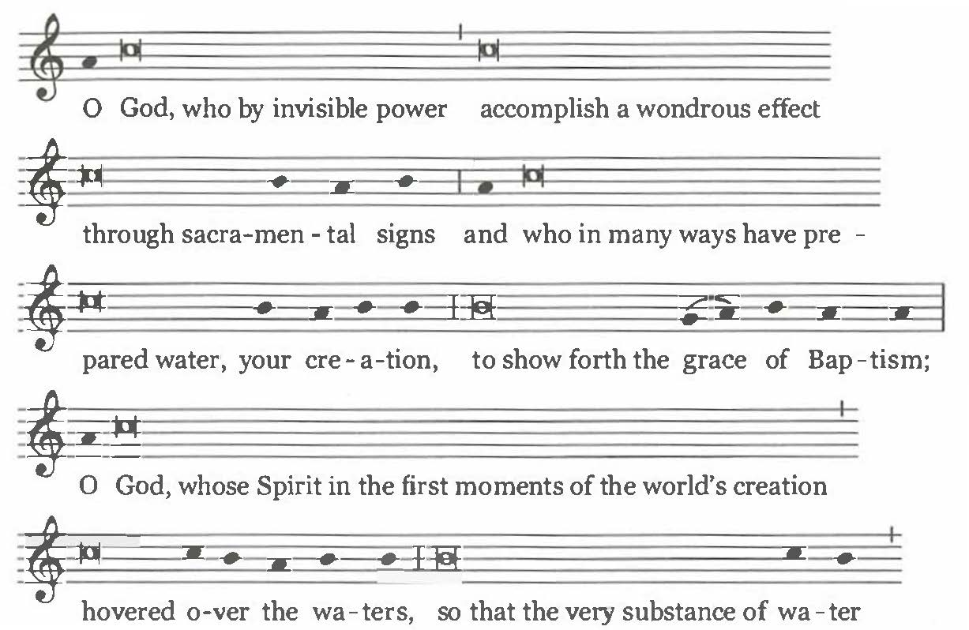

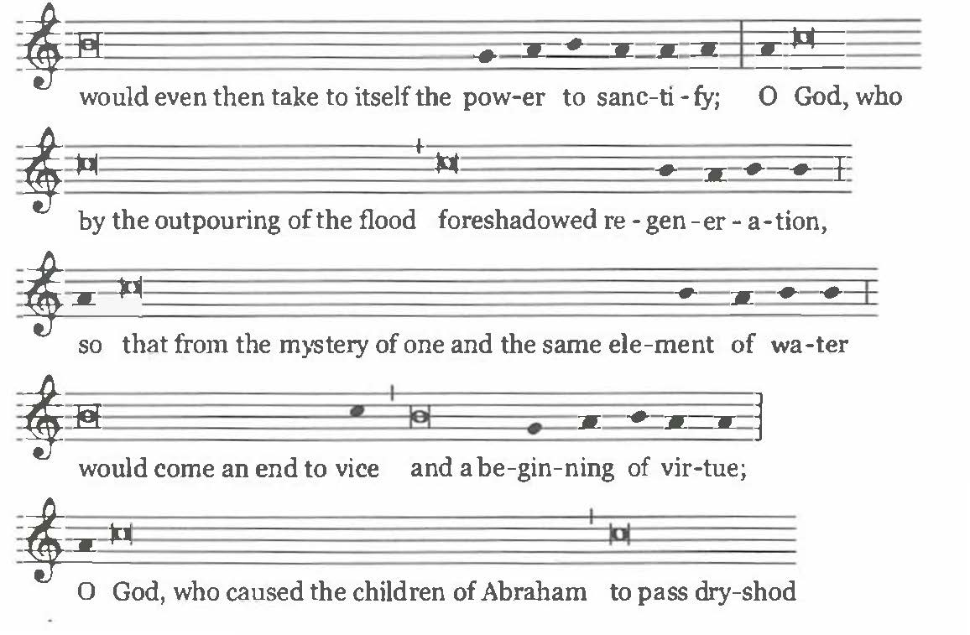
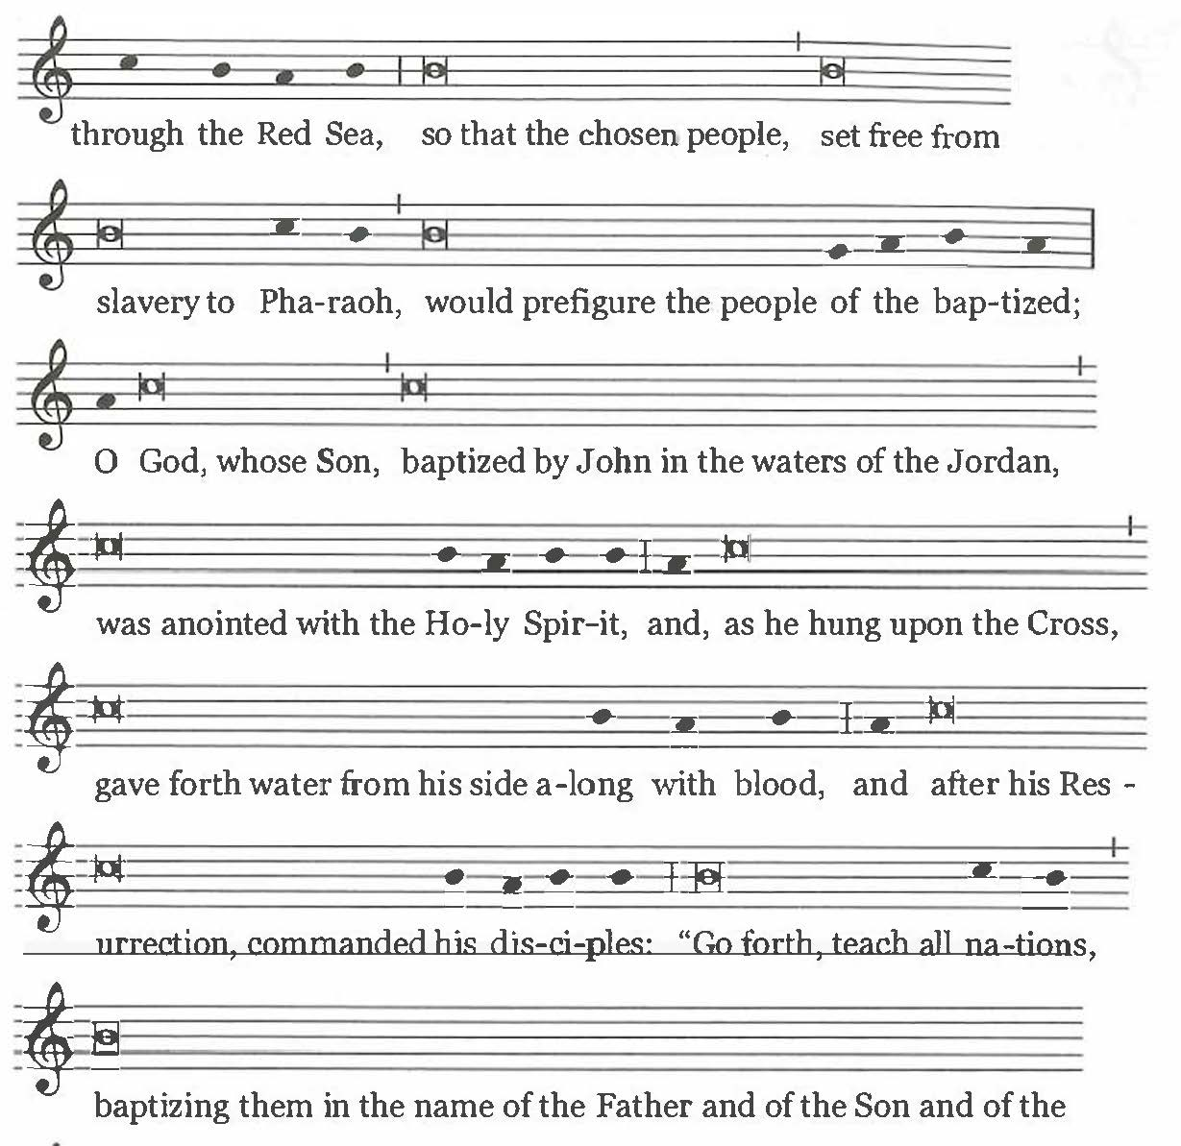
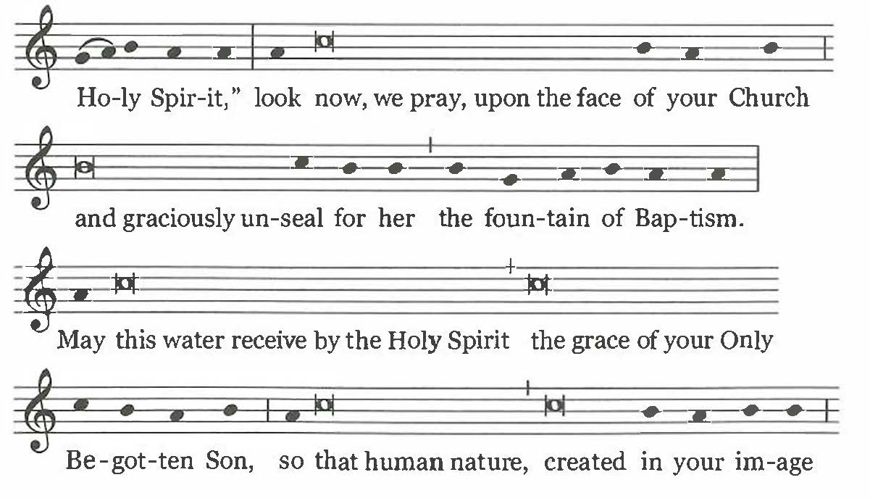
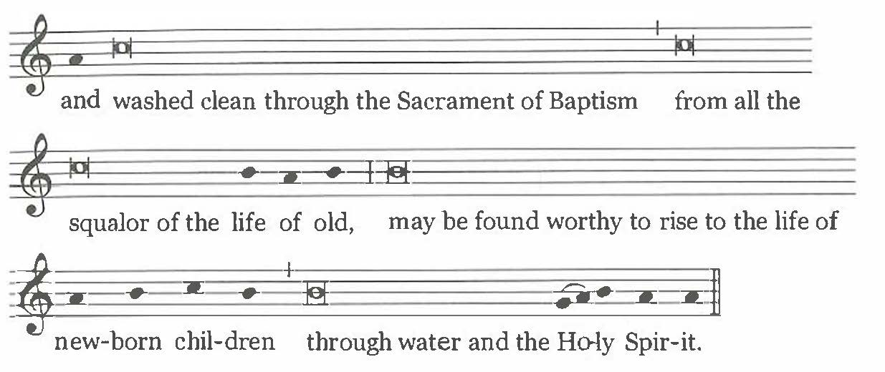

And, if appropriate, lowering the paschal candle into the water either once or three times, he continues:

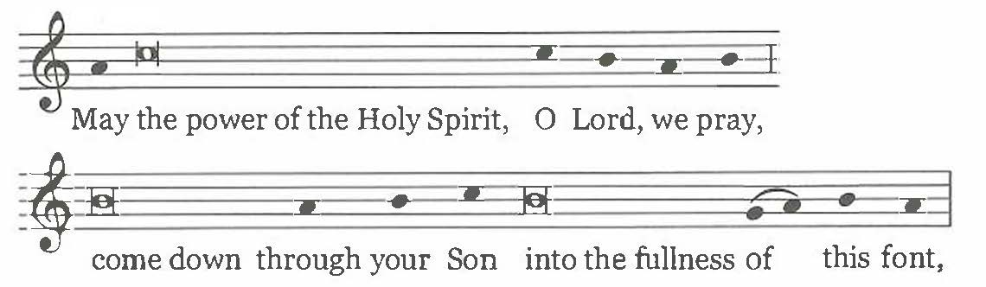

and, holding the candle in the water, he continues:

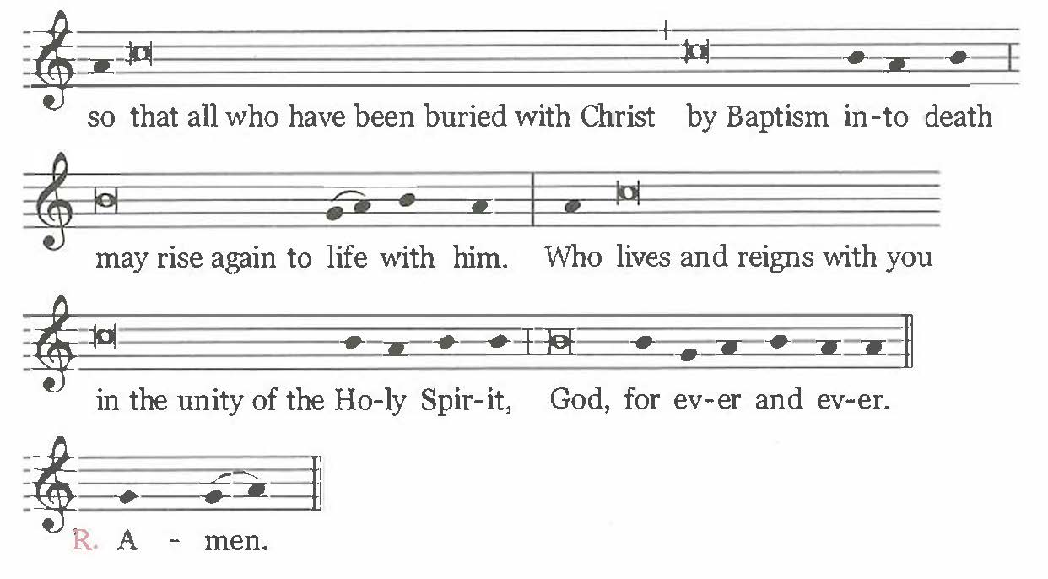

Text without music:

O God, who by invisible power
accomplish a wondrous effect
through sacramental signs
and who in many ways have prepared water, your creation,
to show forth the grace of Baptism;

O God, whose Spirit
in the first moments of the world's creation
hovered over the waters,
so that the very substance of water
would even then take to itself the power to sanctify;

O God, who by the outpouring of the flood
foreshadowed regeneration,
so that from the mystery of one and the same element of water
would come an end to vice and a beginning of virtue;

O God, who caused the children of Abraham
to pass dry-shod through the Red Sea,
so that the chosen people,
set free from slavery to Pharaoh,
would prefigure the people of the baptized;

O God, whose Son,
baptized by John in the waters of the Jordan,
was anointed with the Holy Spirit,
and, as he hung upon the Cross,
gave forth water from his side along with blood,
and after his Resurrection, commanded his disciples:
"Go forth, teach all nations, baptizing them
in the name of the Father and of the Son and of the Holy Spirit,"
look now, we pray, upon the face of your Church
and graciously unseal for her the fountain of Baptism.

May this water receive by the Holy Spirit
the grace of your Only Begotten Son,
so that human nature, created in your image
and washed clean through the Sacrament of Baptism
from all the squalor of the life of old,
may be found worthy to rise to the life of newborn children
through water and the Holy Spirit.
And, if appropriate, lowering the paschal candle into the water either once or three times, he continues:

May the power of the Holy Spirit,
O Lord, we pray,
come down through your Son
into the fullness of this font,

and, holding the candle in the water, he continues:

so that all who have been buried with Christ
by Baptism into death
may rise again to life with him.
Who lives and reigns with you in the unity of the Holy Spirit,
God, for ever and ever.

℟. Amen.

Then the candle is lifted out of the water, as the people acclaim:

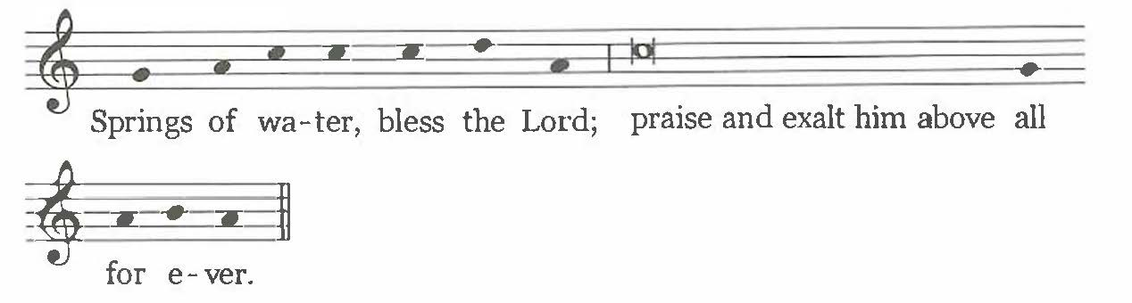

Springs of water, bless the Lord;
praise and exalt him above all for ever.

PROFESSION OF FAITH

572. After the consecration of the font, the celebrant continues with the Profession of Faith, which includes the Renunciation of Sin and the Profession itself.

RENUNCIATION OF SIN

573. As circumstances suggest, the celebrant, informed by the godparents of the name of each person to be baptized, asks each of them, choosing any one of the three formulas below; or he may use the same formulas to question all of the elect together.
At the discretion of the Diocesan Bishop, the formulas for the Renunciation of Sin may be made more specific and detailed as circumstances might require (cf. no. 33.8).

A

Celebrant:

Do you renounce sin,
so as to live in the freedom of the children of God?

Elect (or parents and godparents): I do.

Celebrant:

Do you renounce the lure of evil,
so that sin may have no mastery over you?

Elect (or parents and godparents): I do.

Celebrant:

Do you renounce Satan,
the author and prince of sin?

Elect (or parents and godparents): I do.

B

Celebrant:

Do you renounce Satan,
and all his works and empty promises?

Elect (or parents and godparents): I do.

C

Celebrant:

Do you renounce Satan?
Elect (or parents and godparents): I do.

Celebrant:

And all his works?

Elect (or parents and godparents): I do.

Celebrant:

And all his empty show?

Elect (or parents and godparents): I do.

PROFESSION OF FAITH

574. Then the celebrant, informed again by the godparents of the name of each to be baptized, questions the elect individually. After the Profession of Faith, each one is immediately baptized by immersion or by pouring of water.

When there are a great many to be baptized, the Profession of Faith may be made simultaneously either by all together or group by group.

Celebrant:

N., do you believe in God,
the Father almighty,
Creator of heaven and earth?

Elect (or parents and godparents): I do.

Celebrant:

Do you believe in Jesus Christ, his only Son, our Lord,
who was born of the Virgin Mary,
suffered death and was buried,
rose again from the dead
and is seated at the right hand of the Father?

Elect (or parents and godparents): I do.
Celebrant:
Do you believe in the Holy Spirit,
the holy catholic Church,
the communion of saints,
the forgiveness of sins,
the resurrection of the body,
and life everlasting?

Elect (or parents and godparents): I do.

RITE OF BAPTISM

575. After the Profession of Faith, each elect is immediately baptized by immersion
(option A) or by the pouring of water (option B). After each Baptism, a brief acclamation (c£ Appendix II, nos. 595-597) may be sung by the people.
When there are a great number of the elect to be baptized, if there are several Priests or Deacons present, those to be baptized may be divided into groups among the individual ministers. In baptizing, either by immersion (option A) or by the pouring of water (option B) these ministers say the sacramental formula for each one. While the rite is taking place, singing by the people is desirable; it is also permitted to have readings or to observe sacred silence.

If children are to be baptized, the celebrant asks the parents and godparents of each child:

Is it your will, therefore, that N. should receive Baptism in the faith of
the Church?

Parents and godparents: It is.

A

If Baptism is by immersion of the whole body or of the head only, decency and decorum should be observed. For the Baptism of an adult, either or both godparents touch the one to be baptized. Touching the elect, the celebrant immerses him (her) or his (her) head three times, raising the elect out of the water each time and baptizing him (her) by calling upon the Most Holy Trinity only once:

N., I BAPTIZE YOU IN THE NAME OF THE FATHER,

He immerses the elect the first time.
AND OF THE SON,

He immerses the elect the second time.

AND OF THE HOLY SPIRIT.

He immerses the elect the third time.

B

If, however, Baptism is by the pouring of water, either or both godparents place the right hand on the right shoulder of an adult who is to be baptized, while an infant who is to be baptized is held by a parent or godparent, according to custom. The celebrant, taking baptismal water and pouring it three times on the person's bowed head, baptizes him (her) in the name of the Most Holy Trinity:

N., I BAPTIZE YOU IN THE NAME OF THE FATHER,

He pours water the first time.

AND OF THE SON,

He pours water the second time.

AND OF THE HOLY SPIRIT.

He pours water the third time.

EXPLANATORY RITES

576. The Explanatory Rites (nos. 577-579) are carried out immediately after Baptism. After these rites, Confirmation normally is celebrated, as described below (nos. 587-591), in which case the Anointing after Baptism is omitted.

ANOINTING AFTER BAPTISM

577. For children, and if for some special reason the celebration of Confirmation for an adult or a child of catechetical age is separated from the Baptism (cf. no. 215), then, after the immersion or the pouring of water, the celebrant administers the Anointing with Chrism in the usual way. If, however, there are a large number of newly baptized and several Priests or Deacons are present, each of them may anoint some of the newly baptized with Chrism.

The celebrant says the following over all the newly baptized:

Almighty God, the Father of our Lord Jesus Christ,
has freed you from sin,
given you new birth by water and the Holy Spirit,
and joined you to his people.
He now anoints you with the Chrism of salvation,
so that you may remain members of Christ, Priest, Prophet and King,
unto eternal life.

All: Amen.

Then, in silence, the celebrant anoints each of the newly baptized with sacred Chrism on the crown of the head.

CLOTHING WITH A WHITE GARMENT

578. The celebrant says the following formula. At the words Receive, therefore, the white garment the godparents place the white garment on the newly baptized, unless another color more suited to local custom should be required. If circumstances suggest, this rite can be omitted.

Celebrant:

N. and N., you have become a new creation
and have clothed yourselves in Christ.
Receive, therefore, the white garment
and bring it unstained
before the judgment seat of our Lord Jesus Christ,
that you may have eternal life.

All: Amen.

HANDING ON OF A LIGHTED CANDLE

579. The celebrant then takes the paschal candle in his hands or touches it, saying:

Come forward, godfathers and godmothers,
that you may hand on the light to the newly baptized.

A godparent of each of the neophytes goes to the celebrant, lights a candle from the paschal candle, and presents it to the neophyte.

Then the celebrant says:
You have been made light in Christ.
Walk always as children of light,
that persevering in faith
you may run to meet the Lord when he comes
with all the Saints in the heavenly court.

All: Amen.

RENEWAL OF BAPTISMAL PROMISES

INVITATION

580. When the Rite of Baptism has been completed, all stand, holding lighted candles in their hands, and renew the promise of baptismal faith, unless this has already been done together with those to be baptized (cf. The Roman Missal, The Easter Vigil, no. 49). The candidates for Reception into full communion join the rest of the community in this Renunciation of Sin and Profession of Faith. The Priest addresses the faithful in these or similar words:

Dear brethren ( brothers and sisters), through the Paschal Mystery
we have been buried with Christ in Baptism,
so that we may walk with him in newness of life.
And so, now that our Lenten observance is concluded,
let us renew the promises of Holy Baptism,
by which we once renounced Satan and his works
and promised to serve God in the holy catholic Church.
And so I ask you:

RENUNCIATION OF SIN

581. The celebrant continues with one of the following formulas of renunciation.

If the situation warrants, formula A may be adapted by Conferences of Bishops
according to local needs.

A

Celebrant:
Do you renounce sin,
so as to live in the freedom of the children of God?

All: I do.

Celebrant:

Do you renounce the lure of evil,
so that sin may have no mastery over you?

All: I do.

Celebrant:

Do you renounce Satan,
the author and prince of sin?

All: I do.

B

Celebrant:

Do you renounce Satan?

All: I do.

Celebrant:
And all his works?

All: I do.

Celebrant:

And all his empty show?

All: I do.

PROFESSION OF FAITH

582. Then the celebrant continues:

Do you believe in God,
the Father almighty,
Creator of heaven and earth?

All: I do.

Celebrant:

Do you believe in Jesus Christ, his only Son, our Lord,
who was born of the Virgin Mary,
suffered death and was buried,
rose again from the dead
and is seated at the right hand of the Father?

All: I do.

Celebrant:

Do you believe in the Holy Spirit,
the holy catholic Church,
the communion of saints,
the forgiveness of sins,
the resurrection of the body,
and life everlasting?

All: I do.

And the celebrant concludes:
And may almighty God, the Father of our Lord Jesus Christ,
who has given us new birth by water and the Holy Spirit
and bestowed on us forgiveness of our sins,
keep us by his grace,
in Christ Jesus our Lord,
for eternal life.

All: Amen.

SPRINKLING WITH BAPTISMAL WATER

583. The celebrant sprinkles the people with the blessed water, while all sing
the following or another chant that is baptismal in character:

I saw water flowing from the Temple,
from its right-hand side, alleluia;
and all to whom this water came were saved
and shall say: Alleluia, alleluia. (Cf Ez 47:1-2, 9)

CELEBRATION OF RECEPTION

INVITATION

584. Unless the baptismal washing and the other Explanatory Rites have occurred in the sanctuary, a procession returns to the sanctuary, formed as before, with the newly baptized or the godparents or parents carrying lighted candles. During this procession, the baptismal canticle Vidi aquam (I saw water) or another appropriate chant is sung (The Roman Missal, The Easter Vigil, no. 56).

If children were baptized, they and their parents and godparents return to their places.

Before welcoming the candidates for Reception into the sanctuary, the celebrant may address the congregation in these or similar words:

Dear friends,
this evening we also welcome
into the full communion of the Catholic Church
some brothers and sisters who are already one with us by Baptism:
they are already Christian, and moments ago joined us
in the renewal of our baptismal promises.
Now they will publicly profess the Catholic faith
and so be united with us in the fullness of communion
and be able to join us in the reception of the Holy Eucharist.

Then in the following or similar words the celebrant invites the candidates for Reception, along with their sponsors, to come into the sanctuary and before the community to make a Profession of Faith:

N. and N., since after mature deliberation in the Holy Spirit
and of your own free will
you have asked to be received
into the full communion of the Catholic Church,
I now invite you to come forward with your sponsor
and in the presence of this community
to profess the Catholic faith.
In this faith, today for the first time
you will partake with us at the eucharistic table of the Lord Jesus,
by which the unity of the Church is signified.

PROFESSION BY THE CANDIDATES

585. When the candidates for Reception and their sponsors have taken their places in the sanctuary, the celebrant asks the candidates to make the following Profession of Faith. The candidates say:

I believe and profess
all that the holy Catholic Church
believes, teaches, and proclaims as revealed by God.

FORMULA OF RECEPTION

586. Then the candidates with their sponsors go individually to the celebrant, who says to each candidate (laying his right hand on the head of any candidate who is not to receive Confirmation):

N., the Lord receives you into the Catholic Church.
In his mercy he has led you here,
so that in the Holy Spirit
you may have full communion with us
in the faith you have professed before this his family.

CELEBRATION OF CONFIRMATION

587. Before the celebration of Confirmation, the congregation may, as circumstances
suggest, sing a suitable chant.

588. If the Bishop has conferred Baptism, he should now also administer Confirmation. If the Bishop is not present, Confirmation is to be given by the Priest who conferred Baptism (cf Code of Canon Law, can. 866).

When those to be confirmed are too numerous, Priests who may be designated for this role can be associated to the minister of Confirmation to administer the Sacrament (cf no. 14).

If Confirmation is also to be conferred on some who were baptized as Catholics but who had not received Confirmation, the celebrant may address the congregation in these or similar words:

Dear friends,
finally, we also celebrate the Sacrament of Confirmation,
not only for the newly baptized
and those who just now professed the Catholic faith,
but also, with the permission of Bishop N.,
for some brothers and sisters who were previously baptized as Catholics
but who have not yet received Confirmation.

The celebrant or another minister invites the previously baptized Catholics by name to come forward with their sponsors.

INVITATION

589. The newly baptized with their godparents and, if they have not received the Sacrament of Confirmation, the newly received with their sponsors, together with those baptized as Catholics and their sponsors, stand before the celebrant. He speaks briefly to them in these or similar words:
Dear candidates for Confirmation,
you have been born again in Christ,
and have become members of Christ and of his priestly people.
Now you are to share
in the outpouring among us of the Holy Spirit,
who was sent by the Lord upon the Apostles at Pentecost
to be given by them and their successors to the baptized.

Therefore, you also are to receive the promised power of the Holy Spirit,
so that, being more perfectly conformed to Christ,
you may bear witness to the Lord's Passion and Resurrection
and become an active member of the Church
for the building up of the Body of Christ in faith and charity.

Then the celebrant (while the Priests associated with him remain by his side) standing, facing the people, with hands joined, says:

Dearly beloved,
let us pray to God the almighty Father,
that he will graciously pour out the Holy Spirit
upon these candidates for Confirmation
to confirm them with his abundant gifts,
and through his anointing
conform them more fully to Christ, the Son of God.

And all pray in silence for a while.

THE LAYING ON OF HANDS

590. Then: the celebrant lays hands over all those to be confirmed (as do the Priests who are associated with him). But the celebrant alone says (for the chant, c£ no. 234):

Almighty God, Father of our Lord Jesus Christ,
who brought these your servants to new birth
by water and the Holy Spirit,
freeing them from sin:
send upon them, O Lord, the Holy Spirit, the Paraclete;
give them the spirit of wisdom and understanding,
the spirit of counsel and fortitude,
the spirit of knowledge and piety;
fill them with the spirit of the fear of the Lord.
Through Christ our Lord.

All: Amen.

THE ANOINTING WITH CHRISM

591. The sacred Chrism is brought by a minister to the celebrant.

If other Priests are associated with the celebrant in conferring the Sacrament, the vessels of sacred Chrism are given to them by the Bishop, if he is present.

Each of those to be confirmed goes to the celebrant (or to the Priests); or, if appropriate, the celebrant (and the Priests) goes to each of those to be confirmed. In addition, the godparent places his (her) right hand on the shoulder of the one to be confirmed and says his (her) name to the celebrant; or the one to be confirmed alone says his (her) own name. During the anointing a suitable chant may be sung.

The celebrant dips the tip of the thumb of his right hand in the Chrism and, with the thumb, makes the Sign of the Cross on the forehead of the one to be confirmed, as he says:

N., BE SEALED WITH THE GIFT OF THE HOLY SPIRIT.

The newly confirmed: Amen.

The celebrant adds:

Peace be with you.

The newly confirmed: And with your spirit.

After all have received the Sacrament, the newly confirmed as well as the godparents and sponsors are led to their place among the faithful.

CELEBRATION OF THE EUCHARIST

592. The Creed is omitted, and the Universal Prayer (Prayer of the Faithful), which the neophytes take part in for the first time, immediately takes place. When the offerings are carried to the altar, it is desirable that the bread and wine be brought forward by the newly baptized or, if they are children, by their parents or godparents.

593. In Eucharistic Prayer I, mention of the neophytes is made in the proper form of the Hanc igitur (Therefore, Lord, we pray) from The Roman Missal, Order of Mass, no. 87, and mention of the godparents is made in the section Memento, Domine (Remember, Lord, your servants) from the Ritual Mass for the Conferral of Baptism. If Eucharistic Prayer II, III, or IV is used, the proper formula for the neophytes is used from the Ritual Mass for the Conferral of Baptism.

594. The neophytes, newly received, and newly confirmed may receive Holy Communion under both kinds, together with their godparents, and Catholic parents and spouses, as well as their lay catechists (cf. nos. 243, 498; Order of Confirmation, no. 32). It is even appropriate that, with the consent of the Diocesan Bishop, where the occasion suggests this, all the faithful be admitted to Holy Communion under both kinds.

Before Communion, that is, before Ecce Agnus Dei (Behold the Lamb of God), the celebrant may briefly remind the neophytes of the preeminence of so great a Sacrament, which is the climax of their Initiation and the center of the whole Christian life. He may also mention that for those received into full communion this first full sharing with the Catholic community in Eucharistic Communion is the high point of their Reception. He may do so in these or other words:

Dear neophytes,
on this most sacred night
you have been reborn by water and the Holy Spirit,
and will receive, for the first time,
the Bread of life and the Chalice of salvation.

And you who were previously baptized
and are now completing your Christian Initiation
will also partake in this most blessed Sacrament.

May the Body and Blood of Christ the Lord
help you all to grow deeper in his friendship
and in communion with the entire Church;
may it be your constant food for the journey of life
and a foretaste of the eternal banquet of heaven.

Behold the Lamb of God ...

. Cf. Secretariat for Christian Unity, Ecumenical Directory I, no. 11: Acta Apostolicæ Sedis 59 (1967), pp. 578-579; Second Vatican Council, Decree on Ecumenism, Unitatis redintegratio, no. 3.
Cf. Ecumenical Directory I, no. 11: Acta Apostolicæ Sedis 59 (1967), p. 578; Second Vatican Council, Decree on Ecumenism, Unitatis redintegratio, no. 22.
Cf. Second Vatican Council, Decree on Ecumenism, Unitatis redintegratio, no. 22.

