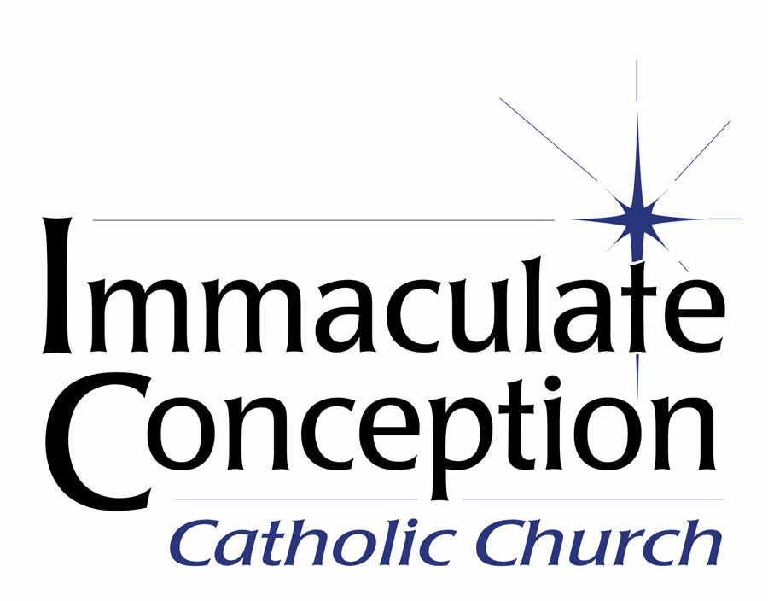

Seeking Director of Music and Liturgy

Immaculate Conception is a large, vibrant and welcoming Roman Catholic community ministering to over 800 households/2000 members in the quaint, historic city of La Grange, Kentucky.

We are prayerfully searching for a full-time Director of Music and Liturgy.

The Director of Music and Liturgy plans music, directs the choir, schedules and trains cantors, lectors, Eucharistic Ministers and sacristans for all liturgies. Church has a Walker organ, Baldwin piano, Yamaha Clavinova, and, sound system.

The parish can offer a competitive salary that will be accompanied by a full benefits package including medical/dental insurance and a matching 401K.

If interested, please submit a curriculum vitae and references to: monica.breitholle@iclagrange.org.

