April 2026- Session 7 The Kerygma & Our Response
Two-hour Session, 7-9 p.m., adjust to your meeting time as needed
7:00 Welcome/Gathering Time
- Serve coffee, water, or wine
7:15 Opening Prayer
- You may lead a spontaneous prayer or use the one on page 43.
- Make sure to leave time for others to share their prayer intentions.
7:20 God Sightings- See page 7 for an explanation.
7:35 Read pages 43-44 and discuss the three questions.
7:50 Proclaim the three readings for the Fourth Sunday of Easter on pages 45-46 and discuss the three questions.
8:10 Play Bishop Medley’s video for Session Seven, which is available on the diocesan website at: https://owensborodiocese.org/in-the-word/ and at these links below:
YouTube - https://youtu.be/HJAlIWEMvOs
Vimeo - https://vimeo.com/1170790838?share=copy&fl=sv&fe=ci
8:15 Discussion: Use the questions on page 47 and discuss Bishop’s reflection.
8:25 Closing Song- Shepherd me, O God
https://www.youtube.com/watch?v=wdiusy9YUYc&list=RDwdiusy9YUYc&start_radio=1
8:30 Closing Prayer is on page 47. Feel free to lead a spontaneous prayer or to invite others to close the evening with prayer as they feel willing.
8:35 Announcements:
- Any parish announcements of events coming up this month in the parish?
- Made for Mission is a special event being held on Thursday, April 30 in Owensboro to help parish teams and parish leaders to envision a dynamic parish culture to bring about greater engagement. The host is the Divine Renovation Ministries and ALPHA. A flyer was emailed to you at the beginning of the month.
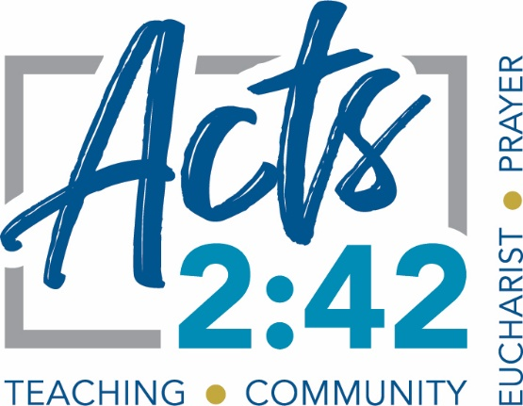
- We are rebranding our Adult Parish Small Group ministry in the diocese to Acts 2:42. Going forward, whatever materials we use in our parish small groups, we will call the groups Act 2:42. More information coming soon! Next year our Acts 2:42 small groups will host a second year of “In the Word with Bishop Medley.” Please invite new people to join your group and we are looking for a Parish Small Group Coordinator in every parish. Contact Jeff if you are willing.

- Please feel free to contact Jeff Andrini with any questions or suggestions for the Office of Evangelization and Discipleship. His email address is on the back cover of this booklet.
8:40 Social time
Plan to have a dessert to share with the group and encourage people to stick around and enjoy one another’s company.
9:00 End
Please contact Jeff with any questions or input, and God bless your gathering. Jeff.andrini@pastoral.org

