Recommended Claims Process
Mutual of Omaha

Short Term Disability:

- Employees can call 1-800-877-5176 to start the claims process.
- A customer service representative will complete Section 1 (Employee Statement) with you.
- Provide your physician’s contact information (phone, fax, email, address).
- After the call, print “Authorization to Disclose Personal and Health Information” form.
- Complete, sign
  - fax to 402-997-1865
  - or scan the completed and signed forms and email to: submitgrpdisinfo@mutualofomaha.com
  - or mail them to: United of Omaha Insurance Company, Group Insurance Claims, 3300 Mutual of Omaha Plaza, Omaha, NE 68175-0001
  - Once a Benefits Claims Specialist (BCS) is assigned (normally 4 business days), the documents can be emailed securely to the assigned BCS.
- A short-term disability claims representative will be assigned to that claim within 4 business days.
- The claims representative will then check the file feed that is set up between employee navigator and Mutual of Omaha claims to gather personal information and policy information.
- That claims representative will contact the benefits department to gather 4 to 5 pieces of information not included on the file feed.
- Last day worked.
- Current/updated salary
- Sick/Vacation days
- Return to work potential.
- Proof of payroll deductions - Only needed when we cannot see the employee on the file feed, and we need to confirm they elected coverage and are paying premiums. This is not needed every time.

Transfer from Short Term Disability to Long Term Disability:
4-6 weeks before short-term disability ends, the short-term disability claims rep assigned refers it to their long-term disability team, then the long-term disability team will gather information from their active short-term disability claim within 4 business days of receipt of notification. NOTE: Provided the employee has coverage and the claim is medically supported to roll into LTD (sometimes this is what can cause delay if we are pending medical records)
- The long-term disability claims representative will reach out via secure email to the benefits department to obtain payroll records and any other information needed (retirement information to see if they have any other income coming in, return to work potential)

Long Term Disability Only:
Email submission is the preferred method.
- The benefits department can give the long-term disability claim form to the employee.
  - https://content.mutualofomaha.com/contactforms/sites/content.mutualofomaha.com.contactforms/files/_forms/454126_Disability%20Claim%20Form_wf_3.pdf?_gl=1*141vbpc*_ga*MTUxMDAzNTQ1LjE2ODcyNzU3MTU.*_ga_J0Z072GW11*MTcwNDM4MjE5OC41LjEuMTcwNDM4MjIyOC4zMC4wLj
- Employees will fill out the information and turn it into Mutual of Omaha.
  - Employees can fax the forms to 402-997-1865
  - Or email it to newdisabilityclaim@mutualofomaha.com (instructions are listed on the forms)
- Employers can initiate the claim online utilizing the link below.
  - https://www3.mutualofomaha.com/group-disability-claim-forms/Gld_electronicClaimForms.html?Form_ID=LTD

As the Employer:
I am… Plan Admin (Employer)
My state is… Kentucky
Select the form you want to complete:
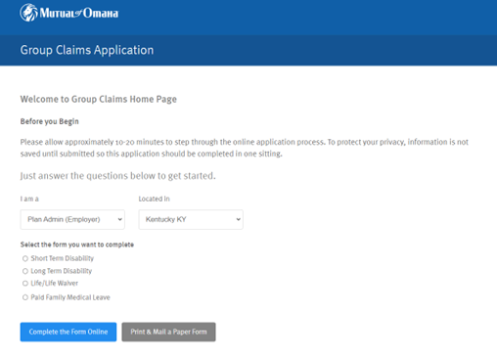

Once LTD is selected, and you click on “complete the form online” it will take you here:
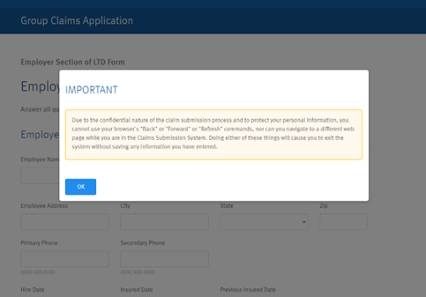
Click OK and complete the claim form.

3. a long-term disability representative gets assigned and they will get personal and policy information from the file feed
4. They will ask for additional information needed from the benefits department via secure email.
5. When approved, the waiver of Premium–notice from long–term disability claims representative–will be mailed to the benefits department to tell them the effective date.
6. The policy document indicates that the Waiver of Premium will occur once the claim is approved, this is automatic.

