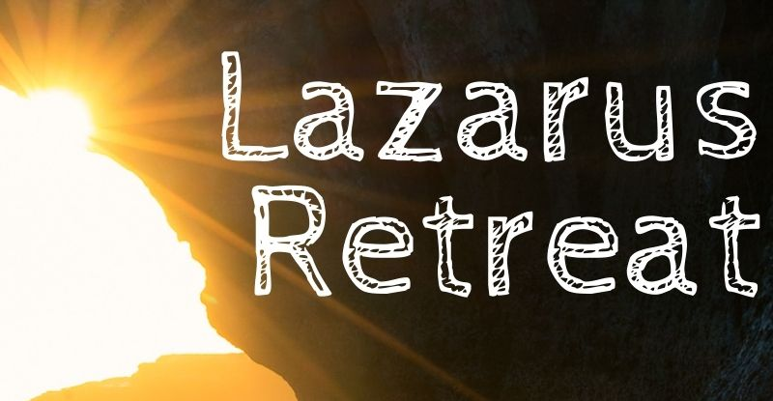
For Parents and Ministry Leaders
What is the Lazarus Retreat all about?

The GOAL of the Lazarus Retreat: The most beautiful goal of the retreat is to provide an opportunity for young people to encounter Jesus Christ, respond to His call to new life and move forward desiring to become disciples.

WHAT THEY WILL EXPERIENCE:
Friday Night: We spend a good amount of time getting them comfortable with a small group for sharing this retreat experience. Each of them is in a group of 4 or 5 youth with a small group leader from around the diocese. The small group leaders are some of the best youth ministry leaders from around the diocese. The night ends with an intensive look at the Kerygma (the good news of Jesus Christ’s life, death, and resurrection)

Saturday: Saturday is a day of talks and prayer experiences. We go through the story of Lazarus (John 11: 1-44) and break it into 4 talks (1) The Community of Concern (2) Lazarus has died (3) Jesus Wept (4) Jesus calls Lazarus to Life. For each talk is a corresponding prayer experience. The goal is for the young people to see that the wage of sin is death, but Jesus wishes to call us to life. There is a community of people pulling for us and supporting us, but we still must choose to hear Jesus call us and respond with discipleship. There are things in our lives, stones that need to be rolled away and things keeping us bound, that keep us from hearing Jesus’ call to life. This night concludes with Adoration and the Sacrament of Reconciliation. The youth are invited into a period of silence for the rest of the night till the morning.

Sunday: We began with a breakfast feast and great celebration! There is one talk (Alive in Christ) which calls the young people forth to be witnesses of the glory of God with their lives for all to see. They are reminded to be in a community of faith in their family, church, school and with their friends. They are also charged with going forth prepared to share their witness with those they may encounter. The retreat experience concludes with the Sunday Mass.

Along the way, each small group leader shares a 3 minute testimony with the youth on how their lives have been impacted by relationship with Jesus Christ.

DETAILS: The cost is $65 per participant, but please let us know if money is an issue. The retreat is held at Gasper River Catholic Youth Camp outside of Bowling Green, KY. We begin on Friday at 5PM (we will have dinner together that night). The retreat ends after Mass on Sunday around 12:30PM. To register, participants need to send in their payment and necessary forms by the deadline before each retreat. Once registered, participants will receive further details for packing and arrival.

Questions: Contact the Office of Youth Ministry (270) 683-1545 or robin.tomes@pastoral.org

