Information Sheet for Inquirers

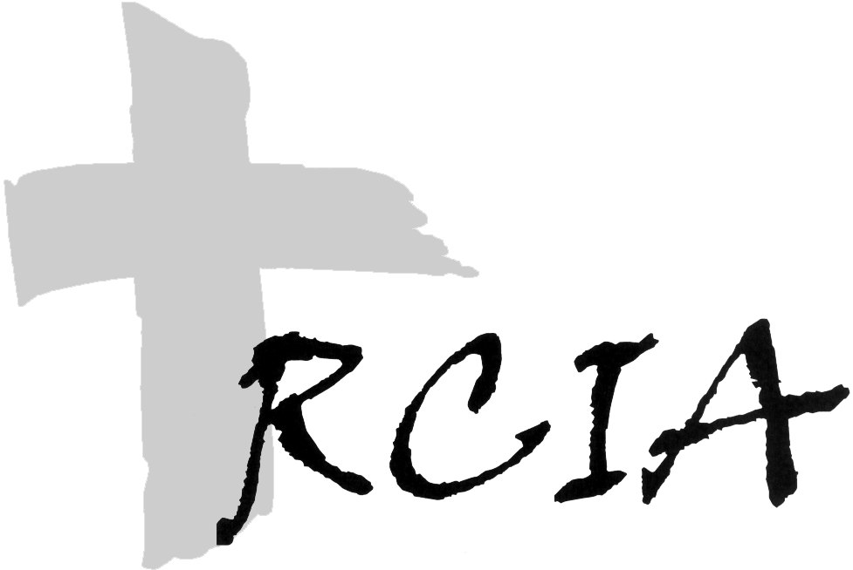

This information should be collected as early as possible in the Inquiry process and most certainly before the celebration of the Rite of Acceptance into the Order of Catechumens or the Rite of Welcome.

Name: ______________________________________________________________________________
Address: ____________________________________________________________________________
Home Phone: __________________________________ Cell Phone: ______________________
Occupation: ____________________________________ Date of birth: _____________________

Baptismal Status

- Have you been baptized: Yes ____ No ____
- Date of Baptism (if known): ____________________________________________________
- Denomination of church of Baptism: ____________________________________________________
- Name and location of church of Baptism:________________________________________________
- Father’s full name: ____________________________________________________
- Mother’s full name (maiden): ____________________________________________________
- Have you ever been accepted as a Catechumen / Candidate in the Catholic Church? _____________
If yes, when: ___________________ where: _____________________________________

Marital Status

Are you: _____ Married _____ Single _____ Engaged _____Other?

If Married . . .
Name of Spouse: ___________________________________________________________
Spouse’s Religious Denomination: __________________________________________________
Church/Place of Marriage: ____________________________________________________
Date of Marriage: ___________________________________________________________
Married by: _____ Minister _____ Priest _____ Civil Official
Is this your first marriage? _____ Yes _____No
Is this your spouse’s first marriage? _____ Yes _____ No

If Engaged . . .
Name of fiancé: _________________________________________________________________
Planned date of marriage: _______________________ Place: _______________________
Has a priest been contacted for marriage preparation? _____ Yes _____ No
Name of priest: _____________________________ City: _______________ State: ______
Will this be your first marriage? _____ Yes _____ No
Will this be the first marriage for your fiancé? _____ Yes _____ No

I have come to inquire about the Catholic Church and faith because:
(check all that apply)

_____ I definitely want to become Catholic.
_____ I think I might want to become a Catholic.
_____ I’m not really sure what has led me here at this time.
_____ I want to learn more about the Catholic faith.
_____ I’m Catholic but have had little or no contact with the church.
_____ I’m Catholic and want to be updated.

Describe your religious training and education: _____________________________________________
_____________________________________________________________________________________
_____________________________________________________________________________________
_____________________________________________________________________________________
_____________________________________________________________________________________

Who or what prompted you to inquire about the Catholic faith? ________________________________
_____________________________________________________________________________________
_____________________________________________________________________________________
_____________________________________________________________________________________
_____________________________________________________________________________________

Which of the members of this parish, if any, do you know already? __________________________
_____________________________________________________________________________________
____________________________________________________________________________________
____________________________________________________________________________________

Name and locations of churches you have attended or been active in:
____________________________________________________________________________________
____________________________________________________________________________________
____________________________________________________________________________________
____________________________________________________________________________________

Any questions or concerns you may have about the RCIA process or the Catholic Church:
____________________________________________________________________________________
____________________________________________________________________________________
____________________________________________________________________________________
____________________________________________________________________________________
____________________________________________________________________________________
____________________________________________________________________________________

Name: _________________________________

If you, your spouse, or your fiancé have been married previously, please fill out the following information for each of the marriages involved.

_____ Myself _____ Spouse _____ Fiancé

Name of Spouse: _________________________________________________________________
Spouse’s Religious Denomination: ________________________________________________________
Church/Place of Marriage: ___________________________________________________________
Date of Marriage: _________________________________________________________________
Married by: _____ Minister _____ Priest _____ Civil Official
Was this your first marriage? _____ Yes _____ No
Was this your spouse’s first marriage: _____ Yes _____ No
Marriage ended by: _____ Death _____ Divorce _____ Annulment
If divorced, date the divorce was finalized: _____________________________________

_____ Myself _____ Spouse _____ Fiancé

Name of Spouse: _________________________________________________________________
Spouse’s Religious Denomination: ________________________________________________________
Church/Place of Marriage: ___________________________________________________________
Date of Marriage: _________________________________________________________________
Married by: _____ Minister _____ Priest _____ Civil Official
Was this your first marriage? _____ Yes _____ No
Was this your spouse’s first marriage: _____ Yes _____ No
Marriage ended by: _____ Death _____ Divorce _____ Annulment
If divorced, date the divorce was finalized: _____________________________________

_____ Myself _____ Spouse _____ Fiancé

Name of Spouse: _________________________________________________________________
Spouse’s Religious Denomination: ________________________________________________________
Church/Place of Marriage: ___________________________________________________________
Date of Marriage: _________________________________________________________________
Married by: _____ Minister _____ Priest _____ Civil Official
Was this your first marriage? _____ Yes _____ No
Was this your spouse’s first marriage: _____ Yes _____ No
Marriage ended by: _____ Death _____ Divorce _____ Annulment
If divorced, date the divorce was finalized: _____________________________________

