May 2026- Session 9, Come Holy Spirit
Two-hour Session, 7-9 p.m., adjust to your meeting time as needed
7:00 Welcome/Gathering Time
- Serve coffee, water, or wine
7:15 Opening Prayer
- You may lead a spontaneous prayer or use the one on page 48.
- Make sure to leave time for others to share their prayer intentions.
7:20 Opening Song- Prayer to the Holy Spirit
https://www.youtube.com/watch?v=nF2bHZ_WUKQ&list=RDnF2bHZ_WUKQ&start_radio=1&t=7s
7:25 God Sightings- See page 7 for an explanation.
7:45 Read pages 48-49 and discuss the three questions.
8:00 Proclaim the three readings for the Fourth Sunday of Easter on pages 50-51 and discuss the three questions.
8:15 Play Bishop Medley’s video for Session Seven, which is available on the diocesan website at: https://owensborodiocese.org/in-the-word/ and at these links below:
YouTube: https://youtu.be/gD6iKe31TPY
Vimeo: https://vimeo.com/1181254359?share=copy&fl=sv&fe=ci
8:20 Discussion: Use the questions on page 52 and discuss Bishop’s reflection.
8:30 Closing Prayer is on page 52. Feel free to lead a spontaneous prayer or to invite others to close the evening with prayer as they feel willing.
8:35 Announcements:
- Any parish announcements of events coming up this month in the parish?
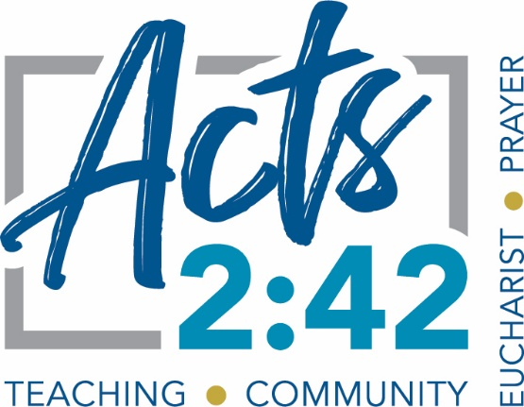
- Our Acts 2:42 parish small groups are a key focus for our Diocese moving forward. We invite your group to continue meeting next fall and to see if you have room for a couple more people to join. Also, we are working with Parish Leadership to ensure each parish has a Parish Small Group Coordinator and to invite new Host Team Leaders to form new groups. Please spread the word! Next year our Acts 2:42 small groups will host a second year of “In the Word with Bishop Medley.”

- Please feel free to contact Jeff Andrini with any questions or suggestions for the Office of Evangelization and Discipleship. His email address is on the back cover of this booklet.
8:40 Social time
Plan to have a dessert to share with the group and encourage people to stick around and enjoy one another’s company.
9:00 End
Please contact Jeff with any questions or input, and God bless your gathering. Jeff.andrini@pastoral.org

