+ ecumenical Taizé prayer
For protection and healing of victims of sexual abuse
Tuesday, April 16, 2024 | 6:00—6:45 p.m. | St. Stephen Cathedral

Prelude: Christ Was Lower Still

“Breathe in, reach out.” …touch the hem of your garment now.
Help me, heal me, my mind, my body and soul.

Let the King descend, Living Word made flesh;
Lift this heavy heart to your throne, O God.
In His wounds I find room for all of mine:
Now in grace I walk, for Christ was lower still.

All:
Humbly, lowly, Jesus waits in the valley.
My Savior suffers with me, with Him, I’ll rise again.

Let the King descend, Living Word made flesh;
Lift this heavy heart to your throne, O God.
In His wounds I find room for all of mine:
…for Christ was lower…

Let the King descend, Living Word made flesh;
Lift this heavy heart to your throne, O God.
In His wounds I find room for all of mine:
… Christ was lower,
Till the earth is filled, Christ is lower still.

We lift it all up to You, Lord. We lift it all up to You, Lord.
We lift our heads, we lift our hands. We lift it all up to You, Lord.
We lift our dreams, we lift our plans. We lift it all up to You, Lord.
We lift our sorrow and our pain. We lift it all up to You, Lord.
We cast our cares on you again. We lift it all up to You, Lord.
We cast our cares on you again. We lift it all up to You, Lord.
We lift it all…

Let the King descend, Living Word made flesh;
Lift this heavy heart to your throne, O God.
In His wounds I find room for all of mine:
… for Christ was lower…

Let the King descend, Living Word made flesh;
Lift this heavy heart to your throne, O God.
In His wounds I find room for all of mine:
…Christ was lower,
Till the earth is filled, Christ is lower still.

Kate Bluett, Doe Jones, Isaac Wardel, Matt Maher
© 2024, The Porter’s Gate. All rights reserved. Used with permission under CCLI license.
_______________________________________________________
Jesus, Remember Me
Jesús, recuérdame cuando entres en tu Reino.
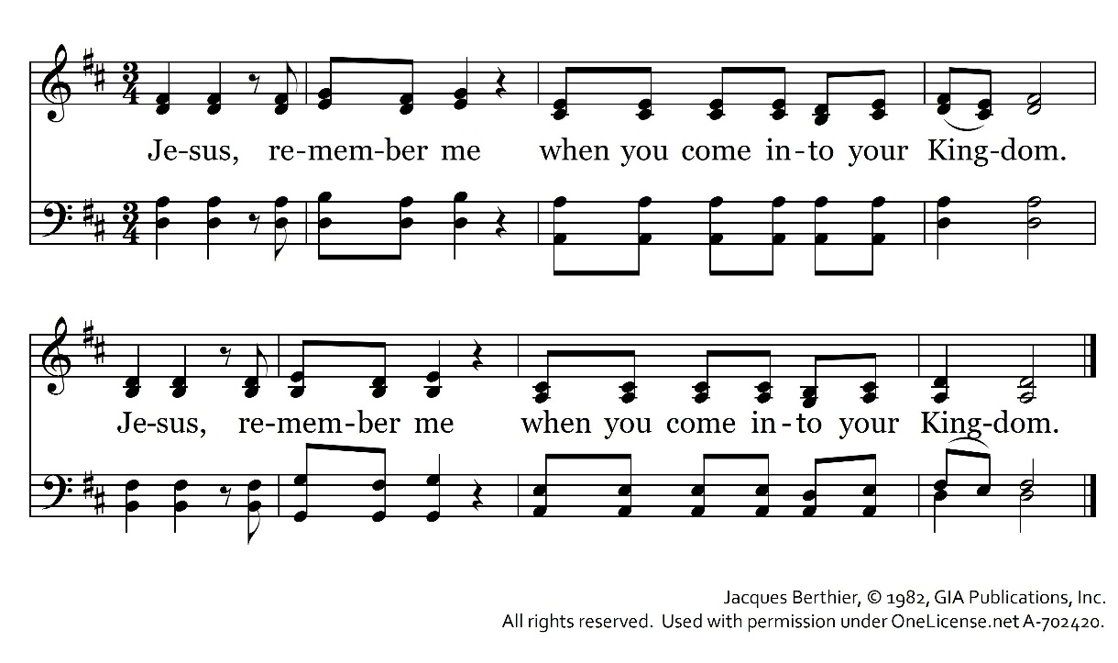
Reading (John 20:19—22)

Homily

Abide in Me
Permanezcan en mí y yo permaneceré en ustedes.
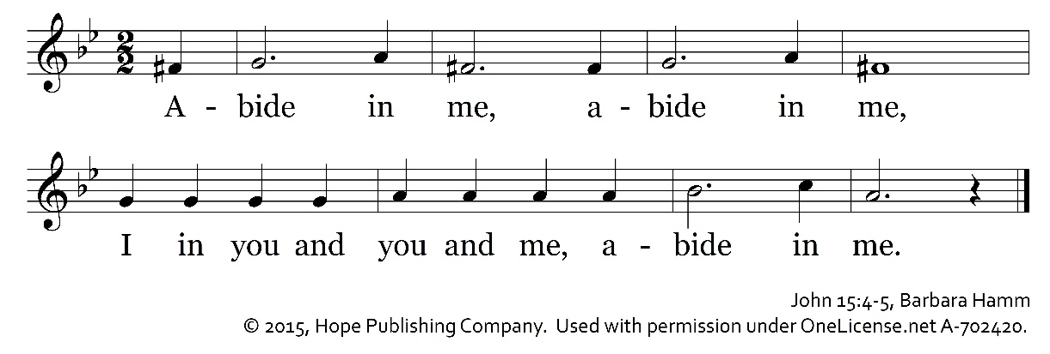
Come, Holy Spirit
Ven, Espíritu Santo, y enciende en ellos el fuego de tu amor.

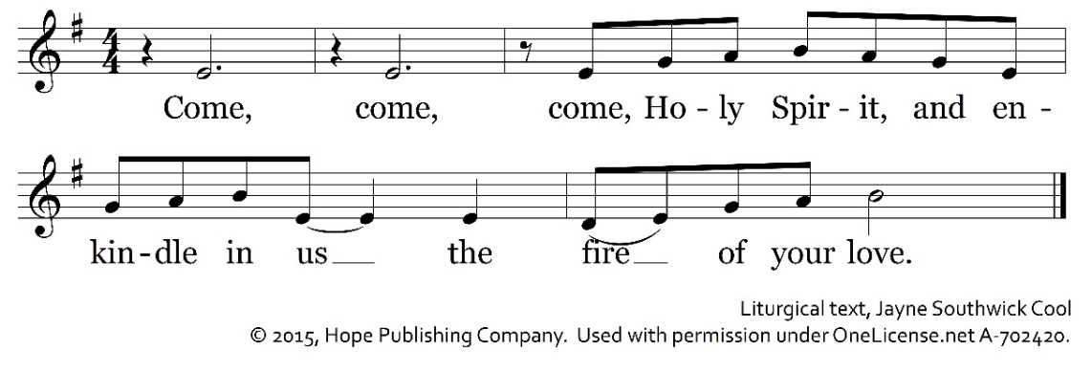
Prayer

Misericordias Domini
Forever will I sing the mercy of the Lord. / Cantare eternamente las misericordia del Señor.
From age to age through all generations, my mouth shall proclaim your praise.
Who, O God, in the universe can compare with you?

Bless the Lord, My Soul (Psalm 103)
The Lord is compassion and love, slow to anger and rich in mercy.
God does not treat us according to our sins no repay us according to our faults.
As a Father has compassion on his children, the Lord has pity on those who fear him;
For God knows of what we are made; God remembers that we are dust.

________________________________________________________________________________________

Please feel free to take a blue candle and a hydrangea home with you.

A video of this evening’s prayer may be found on the cathedral website: https://ststephencathedral.org/

Misericordias Domini, Jacques Berthier, © 1982, GIA Publications, Inc.

Sponsored by the Diocese of Owensboro

