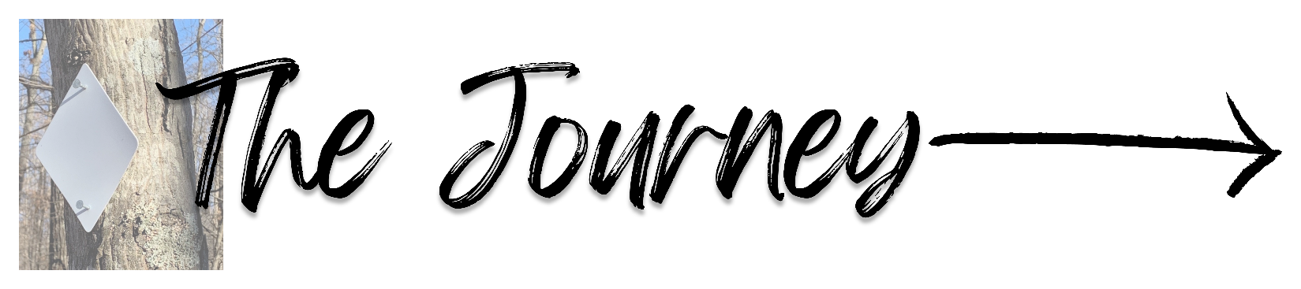

Overview: “Solvitur Ambulando” is a Latin phrase attributed to Saint Augustine which roughly translates to “In walking, it is solved.” It is often hard at times to find the space and time to be available to the loving call and presence of our God. THE JOURNEY is an intentional space for reflection, prayer, fellowship, and adventure hosted by the Office of Youth and Young Adult Ministry utilizing the North Trail at Land between the Lakes.

Cost: $50 per participant (covers six meals, supplies, and fees)

October 23-25, 2026: Participants will need to arrive between 5-6PM on Friday night at St. Henry Catholic Church in Aurora (16097 US-68, Hardin, KY 42048). We will have Mass together, share a meal, programming to set the retreat mindset, and go over trip details. That night we will be sleeping in the parish on the floor. Showers will be available at St Henry.

Saturday will be an early morning as we need to wake up, pack up gear and lunch, spend some time in prayer, eat breakfast, and be on the road ready to hit the trail before 9:00AM. We will take everything with us when we leave St. Henry and will drop most of the vehicles at The Golden Pond Visitor Center. We will then carpool to Smith Bay and start the trail there. One guide will facilitate the retreat and stay with the participants on the trail while the other will drive ahead and set up camp and dinner for the night at Sugar Bay. We will have Mass Saturday Night at the campsite, spend some in reflection and conversation, and have night prayer. The hiking total for Day 1 is around 10.5 miles.

Sunday morning, we will rise early at the campsite to enjoy breakfast and Morning Prayer, pack lunch, tear down camp, and work to be back on trail by 8:30am again. Like the day before, one guide will facilitate the retreat and stay with the participants on the trail while the other will pack up camp and then drive ahead to the Gold Pond Visitor Center. The total hiking for Day 2 is around 12.5 miles. By 4PM, we anticipate all participants to have arrived at the Gold Pond Visitor Center and we will conclude with a closing reflection. We expect the retreat to end by 5PM.

Spiritual Experiences:
We hope to experience a variety of prayer experiences throughout the pilgrimage, both as a community and as individuals. We will offer mass, reflections, and night prayer from liturgy of the hours. The Sacrament of Reconciliation will depend on the availability of priests.

Built into the experience on the hike will be moments of community reflection and conversation and moments of silence and solitude. Each participant will be given a prayer and reflection journal and encouraged to spend time each day documenting their experiences.

On Friday night, participants will be encouraged to articulate a purpose, focus of discernment, or prayer intention for the journey. Participants are asked to keep this point of focus “in front of them” as they reflect and pray, engage in conversation and times of silence, and find success and struggle in the hike. “Solvitur Ambulando,” in walking it is solved.
Individual Equipment- The following gear are our recommendations. Some items on this list are required, while others might be more personal preference. Please feel free to contact me with questions before purchasing new expensive equipment. This gear is not included in the fee. Important to note: We have a trailer with us to carry most of the gear you will use at the campsite like tents, sleeping bags, etc.

__Tent (no larger than 2–4-person capacity) - Can be shared by the same gender or a married couple, but please no co-habitation between mixed genders. We will coordinate with participants as we approach the retreat to see how many tents we need.
__Sleeping Bag (should be rated at least 10 degrees colder than the expected night temperature) and sleeping pad (optional but recommended in colder conditions).
__Good Shoes- comfortable and durable shoes with ankle support. We recommend hiking boots that are broken in or trail running shoes. “Test walk” your shoes for several miles. Bad shoes equal pain and blisters and will make for an unpleasant experience.
__Backpack: It is PARTICULARLY important that your backpack fits you well! If possible get an actual “backpacking” backpack with hip support. At minimum you will be packing your clothing layers for the day, daily water, lunch and snacks, and personal items.
__Trekking Poles or walking stick (especially for those with knee issues)
__Personal first aid kit (band aids, blister care, Ibuprofen, etc.)
__Toiletries (toothbrush, toothpaste, soap, etc. - travel size stuff - keep it light)
__Toilet paper (small quantity)
__Baby wipes for “trail shower”
__Rain poncho
__ANY MEDICATION YOU MAY NEED. BE SURE YOU HAVE WRITTEN ANY AND ALL MEDICATIONS YOU NEED ON THE REGISTRATION FORM SO THE GROUP LEADERS KNOW.
__Small flashlight/headlamp
__Coffee Cup
__Camp Chair
Clothes (AVOID COTTON). Pack light. Think in layers.
__Hiking Pants. Please do not wear jeans. Great pants are ones that can be zipped to become shorts.
__Underwear
__Socks (2 pairs minimum - synthetic/wool). Recommended are Smartwool socks or similar.
__Shirt (wicking), Long sleeve shirt (wicking), Outer Layer (i.e., Light jacket) (will often be cold in mornings)
__Depending on the weather, warm hat, and gloves.
__Water Bladder or bottles (recommended capacity of 3 liters)
__Individual snacks
Individual Packing List of Things that may be useful.
- Camping pillow
- Bug spray
- Sunglasses
- Sunscreen / hat
- Phone + Charger and portable battery (used for communication and emergencies)
- Earplugs - there is a good chance another pilgrim snores.
- A relaxing pair of shoes for when we are not walking (sandals)
- Compeed or other blister care
- Swimsuit if you’re interested in a cold plunge in the lake

